电 子 科 技 大 学 实 验 报 告

课程名称： Python语言程序设计及其应用

实验地点： 科A229

指导教师： 张勇

评 分：

完成实验学生信息：

|  |  |  |  |  |  |
| --- | --- | --- | --- | --- | --- |
| **序** | **姓名** | **学号** | **选课**  **序号** | **贡献**  **百分比(%)** | **备注**  **（主要工作**） |
| 1 | 苏徐涛 | 2022080401011 | 70 | 33 | 1.设计游戏Flappy Bird的改编版  2.进行游戏flying bird的测试和调整 |
| 2 | 付文亮 | 2022080401004 | 69 | 33 | 1.设计游戏欢迎界面（游戏开始前部分）  2.完成实验报告 |
| 3 | 傅若山 | 2022080401023 | 71 | 33 | 1.设计游戏超级马里奥的改编版  2.进行游戏新版马里奥的测试和调整 |
| 4 |  |  |  |  | 1.  2. |

1. 学生人数按照任课教师要求限定；
2. 对于“评价、改进、总结和体会”都要认真填写，和其他内容是评价实验成绩的重要参考。

Pygame游戏制作实践

摘要

Pygame是Python的一个第三方库，具备游戏制作相关功能，适合Python初学者和游戏制作的初学者进行游戏创作实践，本文作者正好利用这一点，进行游戏项目的初创作。创作的游戏分为加载界面和游戏本体两部分，其中游戏本体有两个游戏实体:超级马里奥改编版和Flappy Bird改编版。

关键词：Pygame，游戏项目创作，超级马里奥改编版，Flappy Bird改编版

目 录

摘要 2

**1.** **引言** 4

**2.** **关键技术分析** 4

2.1. Pygame中持续显示界面的分析 4

2.2. Pygame中制作界面的分析 4

2.3. Pygame中涉及音乐的分析 4

2.4. Pygame中涉及图片的分析 4

2.5. Pygame中涉及交互的分析 4

**3.** **系统设计之概要设计** 5

3.1. 这是持续显示界面 5

3.2. 这是制作界面 5

3.3. 这是加载音乐 5

3.4. 这是加载图片 5

3.5. 这是进行交互 5

**4.** **系统设计之详细设计** 6

4.1. 这是持续显示界面 6

4.2. 这是制作界面 6

4.3. 这是加载音乐 7

4.4. 这是加载图片 10

4.5. 这是进行交互 13

**5.** **系统编码** 17

5.1. 傅若山的代码 17

5.1.1. 这是傅若山的background.py 17

5.1.2. 这是傅若山的obstacle.py 17

5.1.3. 这是傅若山的role.py 18

5.1.4. 这是傅若山的process.py 21

5.2. 苏徐涛的代码 26

5.2.1. 这是苏徐涛的game2.py 26

5.2.2. 这是苏徐涛的Class.py 35

5.3. 付文亮的代码 43

5.3.1. 这是付文亮的main.py 43

5.3.2. 这是付文亮的window0.py 44

5.3.3. 这是付文亮的window1.py 44

5.3.4. 这是付文亮的window2.py 46

**6.** **系统测试与应用实例** 49

6.1. 这是程序加载界面 49

6.2. 这是超级马里奥改编版 51

6.3. 这是Flappy Bird的改编版 53

**7.** **本系统优缺点及改进方向** 57

**8.** **心得体会与总结** 57

**9.** **对本实验问题的设计提出改进意见** 57

**参考文献** 58

附件 58

附件 59

附件一：傅若山的源代码 59

附件二：苏徐涛的源代码 68

附件三：付文亮的源代码 86

# **引言**

Pygame中有许多可以用来制作游戏的模块，比如：Mixer模块、Mouse模块、Event模块等。本文是对pygame库进入深入学习后，将所学转换为初步游戏开发的一个大胆尝试。

# **关键技术分析**

## Pygame中持续显示界面的分析

想要让界面持续存在需要使用pygame中的pygame.display.update(),对界面进行不断更新。

## Pygame中制作界面的分析

用pygame呈现出可视化界面，需要使用pygame库中的screen = pygame.display.set_mode(size=( , ),flags= , depth= )进行界面大小等相关功能的设置，使用pygame.display.set_caption(“ ”)设置界面标题，pygame.display.set_icon( )设置界面图标。

## Pygame中涉及音乐的分析

在程序中加载音乐需要使用pygame库中的pygame.mixer.init()进行音乐模块的初始化，然后使用pygame.mixer.music.load(“路径地址及文件后缀”)进行音乐的加载，最后在需要使用的时候使用pygame.mixer.music.play()进行音乐播放。当需要暂停时使用pygame.mixer.music.stop()进行暂停。

## Pygame中涉及图片的分析

在程序中显示图片需要使用pygame库中的pygame.image.load(“路径地址及文件后缀”)进行图片的加载，如果需要调整图片尺寸大小则要使用pygame.transform。scale(“修改对象”，(长度,宽度))，在需要显示图片的时候使用screen.blit(“显示对象”，（x坐标位置 ，y坐标位置）)。

## Pygame中涉及交互的分析

当需要检测外界的输入来进行程序的执行时使用pygame中的pygame.event.get()来不断获取输入的数据，对于鼠标点击的输入事件名称为pygame.MOUSEBUTTONDOWN，获取鼠标点击位置的为pygame中的event.pos[0]和event.pos[1]，前者为x坐标，后者为y坐标；对于鼠标移动的事件名称为pygame.MOUSEMOTION,用于实时获取鼠标位置;对于输入数据进行处理判断下一步执行什么时使用pygame中的碰撞检测：(事件名).collidepoint( 获取的x坐标 , 获取的y坐标)，结果为真则执行其下的代码。

# **系统设计之概要设计**

## 这是持续显示界面

pygame.display.update()

## 这是制作界面

pygame.init()

screen = pygame.display.set_mode(size=(1000,618),flags=0,depth=32)

title = pygame.image.load("图片地址").convert_alpha()

pygame.display.set_caption("界面名称")

pygame.display.set_icon(title)

## 这是加载音乐

pygame.mixer.init()

pygame.mixer.music.load("音乐地址")

pygame.mixer.music.play()

pygame.mixer.music.stop()

## 这是加载图片

picture = pygame.image.load("图片地址").convert_alpha()

Picture = pygame.transform.scale(加载图片变量名, (1000, 618))

screen.blit(加载图片变量名, (图片x坐标, 图片y坐标))

## 这是进行交互

for event in pygame.event.get():

if event.type == QUIT:

pygame.quit()

sys.exit()

if event.type == pygame.MOUSEBUTTONDOWN:

if rect1.collidepoint(event.pos[0], event.pos[1]):

if event.type == MOUSEMOTION:

if event.type==pygame.KEYDOWN:

if event.type==pygame.KEYUP:

# **系统设计之详细设计**

## 这是持续显示界面

while True:

XXXXXXXXXXXXXXXXXX

XXXXXXXXXXXXXXXXXX

XXXXXXXXXXXXXXXXXX

pygame.display.update()

## 这是制作界面

pygame.init()

screen = pygame.display.set_mode(size=(1000,618),flags=0,depth=32)

title = pygame.image.load("sourse1/3.png").convert_alpha()

pygame.display.set_caption("时光机")

pygame.display.set_icon(title)

pygame.init()

screen = pygame.display.set_mode(size=(1000,618),flags=0,depth=32)

title = pygame.image.load("sourse1/3.png").convert_alpha()

pygame.display.set_caption("传送仓")

pygame.display.set_icon(title)

pygame.init()

screen = pygame.display.set_mode(size=(1000,618),flags=0,depth=32)

title = pygame.image.load("sourse1/4.png").convert_alpha()

pygame.display.set_caption("1980年火爆游戏")

pygame.display.set_icon(title)

def __init__(self, fps: int, screen_size: ()):

pygame.init()

self.frame = fps

self.fps = pygame.time.Clock()

pygame.display.set_caption("difficult game by FURUOSHAN")

self.screen_size = screen_size

self.screen = pygame.display.set_mode(screen_size)

self.keep_going = True

self.back = Background(1, screen_size)

self.brick_group1 = pygame.sprite.Group()

self.brick_group2 = pygame.sprite.Group()

self.collide_with_brick = None

self.collide_with_bit = None

self.bit_group = pygame.sprite.Group()

self.role = Role()

self.pause = False

self.trap_tri = [False]*10

self.invincible = False

self.end = None

# 初始化设置，窗口大小，标题，图标展示

pygame.init()

screen=pygame.display.set_mode(size)

pygame.display.set_caption('Flying Bird!')

ico=pygame.image.load('image/Bird_ico.png')

pygame.display.set_icon(ico)

clock=pygame.time.Clock()

## 这是加载音乐

pygame.mixer.init()

pygame.mixer.music.load("music1/4.mp3")

pygame.mixer.music.play()

while True:

screen.blit(Picture, (0, 0))

rect1 = pygame.draw.rect(screen, (255, 255, 255), (1000 / 2 - 240-80, 618 / 2 + 50, 640, 80))

screen.blit(text1, (1000/2-240-80, 618/2+50))

pygame.display.update()

for event in pygame.event.get():

if event.type == QUIT:

pygame.mixer.music.stop()

pygame.quit()

sys.exit()

if event.type == pygame.MOUSEBUTTONDOWN:

if rect1.collidepoint(event.pos[0], event.pos[1]):

pygame.mixer.music.stop()

from window1 import *

pygame.mixer.init()

pygame.mixer.music.load("music1/1.mp3")

pygame.mixer.music.play()

pygame.mixer.init()

for event in pygame.event.get():

if event.type == MOUSEMOTION:

if 0 <=event.pos[0] and 500 >=event.pos[0] and event.pos[1]<=618 and event.pos[1]>=0:

pygame.mixer.music.load("music1/2.mp3")

pygame.mixer.music.play()

if event.pos[0]>500 and event.pos[0]<=1000 and event.pos[1]<=618 and event.pos[1]>=0:

pygame.mixer.music.load("music1/3.mp3")

pygame.mixer.music.play()

pygame.mixer.music.load("music2/jump.wav")

pygame.mixer.music.set_volume(0.2)

class Monster:

def __init__(self):

self.v=7

self.x=900

self.y=random.randint(60,540)

self.size=(60,60)

self.music=pygame.mixer.Sound('music/jump.wav') # 这个音乐是无效的，子类还会单独写各自的音乐

self.music_trigger=False # False代表未播放，True代表已经播放

self.volume=0.3 # 初始音量

self.coll=True # 怪物的碰撞检测，默认开启检测

self.image=True # 怪物图片

self.Rect = pygame.Rect(self.x - self.size[0] / 2.5, self.y - self.size[1] / 2.5, self.size[0] * 0.8,self.size[1] * 0.8)

def appear(self,screen,empty:tuple):

self.playmusic()

self.x -= self.v

screen.blit(self.image,(self.x - self.size[0] / 2, self.y - self.size[1] / 2))

self.Rect = pygame.Rect(self.x - self.size[0] / 2.5, self.y - self.size[1] / 2.5, self.size[0] * 0.8,self.size[1] * 0.8)

if self.x < -80:

self.x=900

self.y=random.randint(60,540)

while self.y>empty[0] and self.y<empty[1]:

self.y = random.randint(60, 540)

self.music_trigger=False

def disappear(self):

self.x = 1200

self.Rect = pygame.Rect(self.x, self.y, self.size[0], self.size[1])

self.v = 0

def playmusic(self):

self.music.set_volume(self.volume)

if not self.music_trigger:

self.music_trigger=True

self.music.play()

## 这是加载图片

picture = pygame.image.load("sourse1/5.png").convert_alpha()

Picture = pygame.transform.scale(picture, (1000, 618))

screen.blit(Picture, (0, 0))

# 导入图片

picturelist = []

picture = ["image3/1.png", "image3/2.png", "image3/3.png", "image3/4.png", "image3/5.png", "image3/6.png", "image3/7.png", "image3/8.png", "image3/9.png", "image3/10.png", "image3/11.png", "image3/12.png", "image3/13.png", "image3/14.png", "image3/15.png", "image3/16.png", "image3/17.png", "image3/18.png", "image3/19.png", "image3/20.png", "image3/21.png", "image3/22.png", "image3/23.png", "image3/24.png", "image3/25.png", "image3/26.png", "image3/27.png", "image3/28.png", "image3/29.png", "image3/30.png", "image3/31.png", "image3/32.png", "image3/33.png", "image3/34.png", "image3/35.png", "image3/36.png", "image3/37.png", "image3/38.png", "image3/39.png", "image3/40.png", "image3/41.png", "image3/42.png", "image3/43.png", "image3/44.png", "image3/45.png", "image3/46.png", "image3/47.png", "image3/48.png", "image3/49.png"]

# 调整图片尺寸

for n in picture:

Picture = pygame.image.load(n).convert_alpha()

PICTURE = pygame.transform.scale(Picture, (1000,618))

picturelist.append(PICTURE)

for i in range(49):

screen.blit(picturelist[i], (0,0))

# 导入图片

picture1 = pygame.image.load("sourse1/1.png").convert_alpha()

Picture1 = pygame.transform.scale(picture1, (60, 60))

picture2 = pygame.image.load("sourse1/2.png").convert_alpha()

Picture2 = pygame.transform.scale(picture2, (80, 80))

picture = ["image1/1.png", "image1/2.png", "image1/3.png", "image1/4.png", "image1/5.png", "image1/6.png", "image1/7.png", "image1/8.png", "image1/9.png", "image1/10.png", "image1/11.png", "image1/12.png", "image1/13.png", "image1/14.png", "image1/15.png", "image1/16.png", "image1/17.png", "image1/18.png", "image1/19.png", "image1/20.png", "image1/21.png", "image1/22.png", "image1/23.png", "image1/24.png", "image1/25.png", "image1/26.png", "image1/27.png"]

picture0 = ["image2/1.png", "image2/2.png", "image2/3.png", "image2/4.png", "image2/5.png", "image2/6.png", "image2/7.png", "image2/8.png", "image2/9.png", "image2/10.png", "image2/11.png", "image2/12.png", "image2/13.png", "image2/14.png", "image2/15.png", "image2/16.png", "image2/17.png", "image2/18.png", "image2/19.png", "image2/20.png", "image2/21.png", "image2/22.png", "image2/23.png", "image2/24.png", "image2/25.png", "image2/26.png", "image2/27.png"]

picturelist0 = []

picturelist = []

# 调整图片尺寸

for n in picture:

PICTURE = pygame.image.load(n).convert_alpha()

Picture = pygame.transform.scale(PICTURE, (1000/2, 618))

picturelist.append(Picture)

for n in picture0:

PICTURE0 = pygame.image.load(n).convert_alpha()

Picture0 = pygame.transform.scale(PICTURE0, (1000 / 2, 618))

picturelist0.append(Picture0)

for i in range(27):

screen.blit(picturelist[i], (1000/2, 0))

screen.blit(picturelist0[i], (0, 0))

class Background(pygame.sprite.Sprite):

def __init__(self, move_v: int, screen_size: ()):

super().__init__()

self.image = pygame.transform.scale(pygame.image.load("picture/background.png"), screen_size).convert()

self.rect = self.image.get_rect()

self.ground = 100

self.move_v = move_v

def move_left(self):

self.rect.x -= self.move_v

def move_right(self):

self.rect.x += self.move_v

def update_move_v(self, move_v: int):

self.move_v = move_v

class Brick(pygame.sprite.Sprite):

def __init__(self, left: int, up: int):

pygame.sprite.Sprite.__init__(self)

self.brick_size = [25, 25]

self.image = pygame.transform.scale(pygame.image.load("picture/brick2.png"), self.brick_size).convert()

self.rect = self.image.get_rect()

self.rect.x = left

self.rect.y = up

class Bit(pygame.sprite.Sprite):

def __init__(self, left: int, up: int, picture: str):

pygame.sprite.Sprite.__init__(self)

self.bit_size = [25, 25]

self.image = pygame.transform.scale(pygame.image.load(f"picture/{picture}"), self.bit_size).convert()

self.image.set_colorkey((255, 255, 255))

self.rect = self.image.get_rect()

self.rect.x = left

self.rect.y = up

self.speed_x = 0

self.speed_y = 0

def update(self):

self.rect.x += self.speed_x

self.rect.y += self.speed_y

self.guandao_up=pygame.image.load('image/管道.png').convert_alpha()

self.guandao_down=pygame.image.load('image/管道.png').convert_alpha()

self.guankou_up=pygame.image.load('image/上管口.png').convert_alpha()

self.guankou_down=pygame.image.load('image/下管口.png').convert_alpha()

self.image=pygame.image.load('image/shell.png').convert_alpha()

self.image=pygame.transform.scale(self.image, self.size)

self.image=pygame.image.load('image/ghost.png').convert_alpha()

self.image=pygame.transform.scale(self.image, self.size)

self.image=pygame.image.load('image/star.png').convert_alpha()

self.image=pygame.transform.scale(self.image, self.size)

self.image=[]

for i in range(6):

i=pygame.image.load(f'image/dragon{i+1}.png').convert_alpha()

i=pygame.transform.scale(i,self.size)

self.image.append(i)

# 背景图片

background1=pygame.image.load('image/background1.png').convert_alpha()

background1=pygame.transform.scale(background1,size)

background2 = pygame.image.load('image/background2.png').convert_alpha()

background2 = pygame.transform.scale(background2, size)

background3 = pygame.image.load('image/background3.png').convert_alpha()

background3 = pygame.transform.scale(background3, size)

# 鸟的图片

bird_size=Bird.size

Image_bird=pygame.image.load('image/Bird.png').convert_alpha()

Image_bird=pygame.transform.scale(Image_bird,(bird_size,bird_size))

Image_bird_dead=pygame.image.load('image/DeadBird.png').convert_alpha()

Image_bird_dead=pygame.transform.scale(Image_bird_dead,(bird_size,bird_size))

## 这是进行交互

for event in pygame.event.get():

if event.type == QUIT:

pygame.mixer.music.stop()

pygame.quit()

sys.exit()

if event.type == pygame.MOUSEBUTTONDOWN:

if rect1.collidepoint(event.pos[0], event.pos[1]):

pygame.mixer.music.stop()

from window1 import *

for event in pygame.event.get():

pygame.mixer.music.stop()

if event.type == QUIT:

pygame.quit()

sys.exit()

for event in pygame.event.get():

if event.type == MOUSEMOTION:

if 0 <=event.pos[0] and 500 >=event.pos[0] and event.pos[1]<=618 and event.pos[1]>=0:

pygame.mixer.music.load("music1/2.mp3")

pygame.mixer.music.play()

if event.pos[0]>500 and event.pos[0]<=1000 and event.pos[1]<=618 and event.pos[1]>=0:

pygame.mixer.music.load("music1/3.mp3")

pygame.mixer.music.play()

if event.type == QUIT:

pygame.mixer.music.stop()

pygame.quit()

sys.exit()

if event.type == pygame.MOUSEBUTTONDOWN and rect1 != None and rect2 != None:

a = event.pos[0]

b = event.pos[1]

if rect1.collidepoint(a, b): # 进入游戏1

pygame.mouse.set_visible(True)

pygame.mixer.music.stop()

from process import *

if rect2.collidepoint(a, b): # 进入游戏2

pygame.mouse.set_visible(True)

pygame.mixer.music.stop()

from game2 import *

if event.type == MOUSEMOTION:

if 0 <= event.pos[0] and 500 >= event.pos[0] and event.pos[1] <= 618 and event.pos[1] >= 0:

pygame.mouse.set_visible(True)

screen.blit(Picture1, (event.pos[0], event.pos[1]))

if event.pos[0] > 500 and event.pos[0] <= 1000 and event.pos[1] <= 618 and event.pos[1] >= 0:

pygame.mouse.set_visible(True)

screen.blit(Picture2, (event.pos[0], event.pos[1]))

for event in pygame.event.get():

if event.type == pygame.QUIT or (event.type == pygame.KEYDOWN and event.key == pygame.K_ESCAPE):

game.keep_going = False

elif event.type == pygame.KEYDOWN:

if event.key == pygame.K_SPACE and game.role.jump_times < game.role.max_jump_times:

game.role.jump_now_v = -game.role.jump_v

game.role.jump_times += 1

pygame.mixer.music.play()

while flag:

for event in pygame.event.get():

if event.type == pygame.KEYDOWN:

flag = False

game = init()

break

elif event.type == pygame.QUIT:

game.keep_going = False

flag = False

break

# 键盘，鼠标轮询

for event in pygame.event.get():

if event.type==pygame.QUIT:

pygame.quit()

sys.exit()

if event.type==pygame.MOUSEBUTTONDOWN and not Status.begin:

Status.music=1

music()

Status.begin = 1

start_time=time.time()

if (event.type ==pygame.MOUSEBUTTONDOWN or event.type==pygame.KEYDOWN and event.key==pygame.K_SPACE) and not Bird.dead and Status.begin:

Bird.jump=True

Bird.g=2

Bird.a=10

music_jump.set_volume(0.3)

music_jump.play()

if event.type==pygame.KEYDOWN and (event.key==pygame.K_LSHIFT or event.key==pygame.K_RSHIFT):

Status.shift=True

if event.type==pygame.KEYUP and (event.key==pygame.K_LSHIFT or event.key==pygame.K_RSHIFT):

Status.shift=False

if event.type==pygame.KEYDOWN and (event.key==pygame.K_LCTRL or event.key==pygame.K_RCTRL):

Status.ctrl=True

if event.type==pygame.KEYUP and (event.key==pygame.K_LCTRL or event.key==pygame.K_RCTRL):

Status.ctrl=False

if event.type==pygame.MOUSEBUTTONDOWN and Status.status in (1,2):

mouse_x,mouse_y=event.pos

if mouse_x > width / 2 - chang / 2+50 and mouse_x<width / 2 - chang / 2+290 and mouse_y>350 and mouse_y<410:

Status.status=4

if mouse_x > width / 2 - chang / 2+350 and mouse_x<width / 2 - chang / 2+590 and mouse_y>350 and mouse_y<410:

pygame.quit()

sys.exit()

# **系统编码**

（核心问题的代码）

## 傅若山的代码

### 这是傅若山的background.py

import pygame

class Background(pygame.sprite.Sprite):

def __init__(self, move_v: int, screen_size: ()):

super().__init__()

self.image = pygame.transform.scale(pygame.image.load("picture/background.png"), screen_size).convert()

self.rect = self.image.get_rect()

self.ground = 100

self.move_v = move_v

def move_left(self):

self.rect.x -= self.move_v

def move_right(self):

self.rect.x += self.move_v

def update_move_v(self, move_v: int):

self.move_v = move_v

### 这是傅若山的obstacle.py

import pygame

class Brick(pygame.sprite.Sprite):

def __init__(self, left: int, up: int):

pygame.sprite.Sprite.__init__(self)

self.brick_size = [25, 25]

self.image = pygame.transform.scale(pygame.image.load("picture/brick2.png"), self.brick_size).convert()

self.rect = self.image.get_rect()

self.rect.x = left

self.rect.y = up

class Bit(pygame.sprite.Sprite):

def __init__(self, left: int, up: int, picture: str):

pygame.sprite.Sprite.__init__(self)

self.bit_size = [25, 25]

self.image = pygame.transform.scale(pygame.image.load(f"picture/{picture}"), self.bit_size).convert()

self.image.set_colorkey((255, 255, 255))

self.rect = self.image.get_rect()

self.rect.x = left

self.rect.y = up

self.speed_x = 0

self.speed_y = 0

def update(self):

self.rect.x += self.speed_x

self.rect.y += self.speed_y

### 这是傅若山的role.py

import pygame

import obstacle

class Role(pygame.sprite.Sprite):

def __init__(self, jump_v=3, move_v=2, g=0.20):

pygame.sprite.Sprite.__init__(self)

self.role_size = [24, 24]

self.picture_standing = pygame.transform.scale(pygame.image.load("picture\\person_standing.png")

.convert_alpha(), self.role_size)

self.picture_left = pygame.transform.scale(pygame.image.load("picture\\person_left.png")

.convert_alpha(), self.role_size)

self.picture_right = pygame.transform.scale(pygame.image.load("picture\\person_right.png")

.convert_alpha(), self.role_size)

self.image = self.picture_standing

self.rect = self.image.get_rect()

self.jump_v = jump_v

self.jump_now_v = 0

self.jump_times = 0

self.move_v = self.move_v_l = self.move_v_r = move_v

self.down = False

self.g = g

self.font1 = self.font2 = None

self.text1 = self.text2 = None

self.max_jump_times = 2

self.errors_v = 10

self.errors_h = 3

# the exact brick width is used here

self.cmp_const_x = (self.rect.width + 25) / 2 - self.errors_h

self.cmp_const_y = (self.rect.width + 25) / 2 - self.errors_v

self.trap_tri = [False * 10]

def move_right(self):

if self.rect.left >= 1361:

return

self.rect.x += self.move_v_r

self.image = self.picture_right

def move_left(self):

if self.rect.right <= 0:

return

self.rect.x -= self.move_v_l

self.image = self.picture_left

def drop(self):

self.rect.y += self.jump_now_v

self.jump_now_v += self.g

def lose(self):

self.font1 = pygame.font.SysFont("Times", 50)

self.text1 = self.font1.render("dead", True, (255, 0, 0))

self.font2 = pygame.font.SysFont("Times", 25)

self.text2 = self.font2.render("input any key to retry", True, (255, 0, 0))

def update(self, screen, *collide):

key = pygame.key.get_pressed()

# restore the initial value

self.move_v_l = self.move_v_r = self.move_v

self.down = True

if collide[0]:

for i in collide[0]:

if self.rect.top < i.rect.top < self.rect.bottom and abs(self.rect.centerx - i.rect.centerx) < \

self.cmp_const_x:

if self.jump_now_v > 0:

self.jump_times = 0

self.jump_now_v = 0

self.rect.bottom = i.rect.top

self.down = False

# if self.jump_now_v > 10: // die of height

# self.lose()

elif self.rect.top < i.rect.bottom < self.rect.bottom and abs(self.rect.centerx -

i.rect.centerx) < self.cmp_const_x:

if self.jump_now_v < 0:

self.jump_now_v = -self.jump_now_v

elif self.rect.left < i.rect.left < self.rect.right and abs(self.rect.centery -

i.rect.centery) < self.cmp_const_y:

self.move_v_r = 0

elif self.rect.left < i.rect.right < self.rect.right and abs(self.rect.centery -

i.rect.centery) < self.cmp_const_y:

self.move_v_l = 0

if self.down:

self.drop()

if self.rect.top > 768:

self.lose()

if collide[1]:

for i in collide[1]:

if pygame.sprite.collide_mask(i, self):

self.lose()

if key[pygame.K_LEFT]:

self.move_left()

elif key[pygame.K_RIGHT]:

self.move_right()

else:

self.image = self.picture_standing

screen.blit(self.image, self.rect)

### 这是傅若山的process.py

"""

by Fu Ruoshan

May 10th, 2023

"""

import pygame

from obstacle import Bit, Brick

from background import Background

from role import Role

import random

import sys

brick_map1 = [[j * 25, 75] for j in range(20)]

brick_map1.extend([[525, j * 25] for j in range(25)])

brick_map1.extend([[450, 125 + i * 50] for i in range(10)])

brick_map1.extend([500, 125 + i * 50] for i in range(10))

brick_map1.extend([475, 125 + i * 50] for i in range(10))

brick_map1.extend([[25 * i, 625] for i in range(25)])

brick_map2 = [[650+50*i, 600-j*50] for i in range(10) for j in range(10)]

bit_map = [[450, i*100+50] for i in range(5)]

bit_map.append([1100, 100])

bit_map.extend([[25*i, 600] for i in range(20)])

bit_trap = [[0, 75], [0, 300]]

class Game(object):

def __init__(self, fps: int, screen_size: ()):

pygame.init()

self.frame = fps

self.fps = pygame.time.Clock()

pygame.display.set_caption("difficult game by FURUOSHAN")

self.screen_size = screen_size

self.screen = pygame.display.set_mode(screen_size)

self.keep_going = True

self.back = Background(1, screen_size)

self.brick_group1 = pygame.sprite.Group()

self.brick_group2 = pygame.sprite.Group()

self.collide_with_brick = None

self.collide_with_bit = None

self.bit_group = pygame.sprite.Group()

self.role = Role()

self.pause = False

self.trap_tri = [False]*10

self.invincible = False

self.end = None

def update(self):

self.screen.blit(self.back.image, self.back.rect)

self.end = pygame.draw.circle(self.screen, (255, 255, 0), (1175, 150), 25)

pygame.draw.circle(self.screen, (255, 0, 0), (1175, 150), 15)

pygame.draw.circle(self.screen, (0, 0, 255), (1175, 150), 5)

self.brick_group1.draw(self.screen)

self.brick_group2.draw(self.screen)

self.bit_group.update()

self.bit_group.draw(self.screen)

self.collide_with_brick = pygame.sprite.spritecollide(self.role, self.brick_group1, False)

self.collide_with_brick.extend(pygame.sprite.spritecollide(self.role, self.brick_group2, False))

for i in self.collide_with_brick:

if i.rect.x >= 650:

if not random.randint(0, 20):

for j in self.brick_group2:

if j.rect == i.rect:

self.brick_group2.remove(j)

if not self.invincible:

self.collide_with_bit = pygame.sprite.spritecollide(self.role, self.bit_group, False)

self.role.update(self.screen, self.collide_with_brick, self.collide_with_bit)

for i in self.bit_group:

if 0 <= i.rect.x <= 1366 and 0 <= i.rect.y <= 768:

continue

self.bit_group.remove(i)

pygame.display.update()

def add_brick_group1(self, *sprite):

pygame.sprite.Group.add(self.brick_group1, sprite)

def add_brick_group2(self, *sprite):

pygame.sprite.Group.add(self.brick_group2, sprite)

def add_bit_group(self, *sprite):

pygame.sprite.Group.add(self.bit_group, sprite)

def creat_role(self, *pos):

self.role.rect.x = pos[0]

self.role.rect.y = pos[1]

def trap(self):

if self.role.rect.bottom > bit_trap[0][1]+5 and not self.trap_tri[0]:

self.trap_tri[0] = True

t = Bit(bit_trap[0][0], bit_trap[0][1], "bit_horizontal_left.png")

t.speed_x = 100

self.add_bit_group(t)

if self.role.rect.bottom > bit_trap[1][1]+5 and not self.trap_tri[1]:

self.trap_tri[1] = True

t = Bit(bit_trap[1][0], bit_trap[1][1]+10, "bit_horizontal_left.png")

t.speed_x = 100

self.add_bit_group(t)

for i in self.brick_group1:

if i.rect.x == 525 and i.rect.y == 300:

self.brick_group1.remove(i)

break

def if_win(self):

if 1150 < self.role.rect.x < 1200 and 125 < self.role.rect.y < 175:

return True

return False

def init():

game1 = Game(60, (1366, 768))

game1.add_brick_group1(Brick(i[0], i[1]) for i in brick_map1)

game1.add_brick_group2(Brick(i[0], i[1]) for i in brick_map2)

game1.add_bit_group(Bit(i[0], i[1], "bit_horizontal_left.png") for i in bit_map)

game1.creat_role(25, 25)

pygame.mixer.music.load("music2/jump.wav")

pygame.mixer.music.set_volume(0.2)

return game1

game = init()

pygame.init()

flag = False

while game.keep_going:

game.fps.tick(game.frame)

game.trap()

for event in pygame.event.get():

if event.type == pygame.QUIT or (event.type == pygame.KEYDOWN and event.key == pygame.K_ESCAPE):

game.keep_going = False

elif event.type == pygame.KEYDOWN:

if event.key == pygame.K_SPACE and game.role.jump_times < game.role.max_jump_times:

game.role.jump_now_v = -game.role.jump_v

game.role.jump_times += 1

pygame.mixer.music.play()

# invincible mode

if pygame.key.get_pressed()[pygame.K_TAB]:

game.invincible = True

else:

game.invincible = False

game.update()

if game.if_win():

font1 = pygame.font.SysFont("Times", 50)

text1 = font1.render("YOU WIN", True, (255, 0, 0))

game.screen.blit(text1, game.role.rect)

pygame.display.update()

flag = True

while flag:

for event in pygame.event.get():

if (event.type == pygame.KEYDOWN and event.key == pygame.K_ESCAPE) or event.type == pygame.QUIT:

flag = False

game.keep_going = False

break

if game.role.text1:

if game.role.rect.left < 0:

game.role.rect.left = 0

if game.role.rect.right > 1100:

game.role.rect.right = 1100

if game.role.rect.top < 0:

game.role.rect.top = 0

if game.role.rect.bottom > 650:

game.role.rect.bottom = 650

game.screen.blit(game.role.text1, game.role.rect)

game.screen.blit(game.role.text2, (game.role.rect.x, game.role.rect.y + 50))

pygame.display.update()

flag = True

while flag:

for event in pygame.event.get():

if event.type == pygame.KEYDOWN:

flag = False

game = init()

break

elif event.type == pygame.QUIT:

game.keep_going = False

flag = False

break

pygame.quit()

sys.exit()

## 苏徐涛的代码

### 这是苏徐涛的game2.py

'''

Content:Flying Bird Game

Author:苏徐涛

'''

import sys

import time

import pygame

# 窗口大小

width=900;height=600

from Class import *

size=(width,height)

chang=600;gao=300

da_xiao=(chang,gao)

def UpdateMap():

'''

展示小鸟、管道、怪物、背景

'''

# 三个阶段

if Bird.score//10==0 or Pipeline1.isappear:

screen.blit(background1,(0,0))

# 显示上管道

screen.blit(Pipeline1.guandao_up, (Pipeline1.x, Pipeline1.up_guandao))

screen.blit(Pipeline1.guankou_up, (Pipeline1.x - 12, Pipeline1.up_guankou))

# 显示下管道

screen.blit(Pipeline1.guandao_down, (Pipeline1.x, Pipeline1.down_guandao))

screen.blit(Pipeline1.guankou_down, (Pipeline1.x - 12, Pipeline1.down_guankou))

Pipeline1.appear()

if Pipeline1.x == Bird.x:

Bird.score += 1

elif Bird.score//10==1 or Pipeline2.isappear:

screen.blit(background2,(0,0))

# 显示上管道

screen.blit(Pipeline2.guandao_up, (Pipeline2.x, Pipeline2.up_guandao))

screen.blit(Pipeline2.guankou_up, (Pipeline2.x - 12, Pipeline2.up_guankou))

# 显示下管道

screen.blit(Pipeline2.guandao_down, (Pipeline2.x, Pipeline2.down_guandao))

screen.blit(Pipeline2.guankou_down, (Pipeline2.x - 12, Pipeline2.down_guankou))

Pipeline2.appear()

if Pipeline2.x == Bird.x:

Bird.score += 1

elif Bird.score//10==2:

if Bird.score==20 and Status.music!=-2:

Status.music=2

music()

screen.blit(background3,(0,0))

# 显示上管道

screen.blit(Pipeline3.guandao_up, (Pipeline3.x, Pipeline3.up_guandao))

screen.blit(Pipeline3.guankou_up, (Pipeline3.x - 12, Pipeline3.up_guankou))

# 显示下管道

screen.blit(Pipeline3.guandao_down, (Pipeline3.x, Pipeline3.down_guandao))

screen.blit(Pipeline3.guankou_down, (Pipeline3.x - 12, Pipeline3.down_guankou))

Pipeline3.appear()

if Pipeline3.x == Bird.x and Bird.score >= 28:

Bird.score += 0.5

elif Pipeline3.x == Bird.x:

Bird.score += 1

# 显示怪物

if Bird.score>5:

Shell1.appear(screen,Pipeline1.empty)

if Bird.score>10:

Shell2.appear(screen,Pipeline2.empty)

if Bird.score>15:

Shell2.disappear()

Dragon.appear(screen,Pipeline2.empty)

if Bird.score>20:

Ghost.appear(screen,Pipeline3.empty)

if Bird.score>22:

Star.appear(screen,Pipeline3.empty)

# 公布得分和时间

screen.blit(time_text,(0,0))

screen.blit(score_text,(0,50))

if Bird.score==10 and Pipeline1.x<=-80:

Pipeline1.disappear()

if Bird.score==20 and Pipeline2.x<=-80:

Pipeline2.disappear()

if Bird.dead:

Bird.status=2

elif Bird.jump:

Bird.status=1

Status.Bird=(Bird.x,Bird.y)

screen.blit(Image_bird,Status.Bird)

Bird.up_down()

def CheckDead():

'''

检测小鸟是否死亡

'''

if Bird.y < -40 or Bird.y > 600:

Bird.dead = True

if Status.ctrl:

return 0

# 检测怪物

Rect=Shell1.Rect,Shell2.Rect,Dragon.Rect,Ghost.Rect,Star.Rect

for i in range(len(Rect)):

if Bird.birdRect.colliderect(Rect[i]) and i<3:

Bird.dead=True

if Bird.birdRect.colliderect(Rect[i]) and i==3 and Ghost.coll==True:

Bird.dead=True

if Bird.birdRect.colliderect(Rect[i]) and i==4 and Star.coll==True:

Bird.dead=True

# 检测管道

rect=Pipeline1.guandao_up_Rect,Pipeline1.guankou_up_Rect,Pipeline1.guandao_down_Rect,Pipeline1.guankou_down_Rect,Pipeline2.guandao_up_Rect,Pipeline2.guankou_up_Rect,Pipeline2.guandao_down_Rect,Pipeline2.guankou_down_Rect,Pipeline3.guandao_up_Rect,Pipeline3.guankou_up_Rect,Pipeline3.guandao_down_Rect,Pipeline3.guankou_down_Rect

for i in range(len(rect)):

if Bird.birdRect.colliderect(rect[i]):

Bird.dead=True

# 小鸟死亡后换遗像

if Bird.dead==True:

screen.blit(Image_bird_dead, Status.Bird)

def music():

if Status.music == 1:

Status.music = -1

music_begin.stop()

music_pos1.set_volume(0.3)

music_pos1.play()

elif Status.music == 2:

Status.music = -2

music_pos1.stop()

music_pos2.set_volume(0.3)

music_pos2.play()

elif Status.music == 3:

Status.music = -3

music_pos2.stop()

music_victory.set_volume(0.3)

music_victory.play()

elif Status.music == 4:

Status.music = -4

music_pos1.stop()

music_pos2.stop()

music_failure.set_volume(0.3)

music_failure.play()

elif Status.music == 5:

Status.music=1

music_failure.stop()

music_victory.stop()

# 初始化设置，窗口大小，标题，图标展示

pygame.init()

screen=pygame.display.set_mode(size)

pygame.display.set_caption('Flying Bird!')

ico=pygame.image.load('image/Bird_ico.png')

pygame.display.set_icon(ico)

clock=pygame.time.Clock()

# 类的初始化

Status=Status()

Bird=Bird()

Pipeline1=Pipeline1()

Pipeline2=Pipeline2()

Pipeline3=Pipeline3()

Dragon=Dragon()

Shell1=Shell()

Shell2=Shell()

Ghost=Ghost()

Star=Star()

# 背景图片

background1=pygame.image.load('image/background1.png').convert_alpha()

background1=pygame.transform.scale(background1,size)

background2 = pygame.image.load('image/background2.png').convert_alpha()

background2 = pygame.transform.scale(background2, size)

background3 = pygame.image.load('image/background3.png').convert_alpha()

background3 = pygame.transform.scale(background3, size)

# 鸟的图片

bird_size=Bird.size

Image_bird=pygame.image.load('image/Bird.png').convert_alpha()

Image_bird=pygame.transform.scale(Image_bird,(bird_size,bird_size))

Image_bird_dead=pygame.image.load('image/DeadBird.png').convert_alpha()

Image_bird_dead=pygame.transform.scale(Image_bird_dead,(bird_size,bird_size))

# 音乐

channel=pygame.mixer.find_channel(True)

channel_jump=pygame.mixer.find_channel(True)

channel_jump.set_volume(0.2)

music_begin=pygame.mixer.Sound('music/助手.mp3')

music_pos1=pygame.mixer.Sound('music/询问2.mp3')

music_pos2=pygame.mixer.Sound('music/询问2+.mp3')

music_victory=pygame.mixer.Sound('music/胜诉3.mp3')

music_failure=pygame.mixer.Sound('music/真相的苦涩味.mp3')

music_jump=pygame.mixer.Sound('music/jump.wav')

channel.play(music_begin)

# 字体和文本

start_font=pygame.font.SysFont(' SimHei', 60)

start_text=start_font.render('Click to start!', True, 'blue')

info_font=pygame.font.SysFont(' SimHei',30)

info_text=info_font.render('''按鼠标或空格键进行跳跃,按shift键进行冲刺''',True,'darkblue')

score_font=pygame.font.SysFont(' SimHei',50)

time_font = pygame.font.SysFont(' SimHei', 50)

settle_font=pygame.font.SysFont(' SimHei',60)

settle_font2=pygame.font.SysFont(' SimHei',40)

choice_font=pygame.font.SysFont(' SimHei',60)

# 游戏主体

while 1:

clock.tick(60)

if Status.status==4:

# 重新开始

Status.__init__()

Bird.__init__()

Pipeline1.__init__()

Pipeline2.__init__()

Pipeline3.__init__()

Ghost.__init__()

Shell1.__init__()

Shell2.__init__()

Star.__init__()

Dragon.__init__()

music_victory.stop()

music_failure.stop()

channel.set_volume(0.3)

channel.play(music_begin)

continue

if Bird.dead:

time.sleep(1)

Status.status=2

if Bird.score==30:

if Status.music == -2:

Status.music=3

music()

Status.status=1

time.sleep(0.5)

# 键盘，鼠标轮询

for event in pygame.event.get():

if event.type==pygame.QUIT:

pygame.quit()

sys.exit()

if event.type==pygame.MOUSEBUTTONDOWN and not Status.begin:

Status.music=1

music()

Status.begin = 1

start_time=time.time()

if (event.type ==pygame.MOUSEBUTTONDOWN or event.type==pygame.KEYDOWN and event.key==pygame.K_SPACE) and not Bird.dead and Status.begin:

Bird.jump=True

Bird.g=2

Bird.a=10

music_jump.set_volume(0.3)

music_jump.play()

if event.type==pygame.KEYDOWN and (event.key==pygame.K_LSHIFT or event.key==pygame.K_RSHIFT):

Status.shift=True

if event.type==pygame.KEYUP and (event.key==pygame.K_LSHIFT or event.key==pygame.K_RSHIFT):

Status.shift=False

if event.type==pygame.KEYDOWN and (event.key==pygame.K_LCTRL or event.key==pygame.K_RCTRL):

Status.ctrl=True

if event.type==pygame.KEYUP and (event.key==pygame.K_LCTRL or event.key==pygame.K_RCTRL):

Status.ctrl=False

if event.type==pygame.MOUSEBUTTONDOWN and Status.status in (1,2):

mouse_x,mouse_y=event.pos

if mouse_x > width / 2 - chang / 2+50 and mouse_x<width / 2 - chang / 2+290 and mouse_y>350 and mouse_y<410:

Status.status=4

if mouse_x > width / 2 - chang / 2+350 and mouse_x<width / 2 - chang / 2+590 and mouse_y>350 and mouse_y<410:

pygame.quit()

sys.exit()

# 按shift实现冲刺，按ctrl实现无敌

if Status.shift:

Pipeline1.v = 10

Pipeline2.v = 10

Pipeline3.v = 10

Ghost.v = 12

Shell1.v = 12

Shell2.v = 12

Dragon.v = -2

else:

Pipeline1.v = 5

Pipeline2.v = 5

Pipeline3.v = 5

Ghost.v = 7

Shell1.v = 7

Shell2.v = 7

Dragon.v = -7

# 其他事件

if Status.status==0:

if Status.begin:

score_text = score_font.render(f'得分：{Bird.score}', True, 'purple')

Status.time=time.time()-start_time

time_text = time_font.render('时间：%.2f' % (Status.time), True, 'blue')

UpdateMap()

CheckDead()

else:

screen.blit(background1,(0,0))

screen.blit(start_text, (250, 130))

screen.blit(info_text,(0,570))

screen.blit(Image_bird, (width / 2 - bird_size / 2, height / 2 - bird_size / 2))

elif Status.status==1:

settle_text1 = settle_font.render('恭喜你，游戏成功! ', True, 'magenta')

settle_text2 = settle_font2.render('得分：%d 用时：%.2f' % (Bird.score, Status.time), True, 'red')

choice_text1 = choice_font.render('重新开始', True, '#0066ff', 'pink')

choice_text2 = choice_font.render('退出游戏', True, '#0066ff', 'pink')

screen.blit(settle_text1, (width / 2 - chang / 2 + 60, height / 2 - gao / 2))

screen.blit(settle_text2, (width / 2 - chang / 2 + 100, height / 2 - gao / 2 + 100))

screen.blit(choice_text1, (width / 2 - chang / 2 + 50, 350))

screen.blit(choice_text2, (width / 2 - chang / 2 + 350, 350))

elif Status.status==2:

if Status.music in (-1,-2) and Status.music!=-4:

Status.music=4

music()

settle_text1 = settle_font.render('很遗憾，游戏失败! ', True, 'black')

settle_text2 = settle_font2.render('得分：%d 用时：%.2f' % (Bird.score, Status.time), True, 'darkblue')

choice_text1=choice_font.render('重新开始',True,'#000033','#99ff99')

choice_text2=choice_font.render('退出游戏',True,'#000033','#99ff99')

screen.blit(settle_text1, (width / 2 - chang / 2+60, height / 2 - gao / 2))

screen.blit(settle_text2, (width / 2 - chang / 2+100, height / 2 - gao / 2 + 100))

screen.blit(choice_text1, (width / 2 - chang / 2+50,350))

screen.blit(choice_text2, (width / 2 - chang / 2+350,350))

pygame.display.flip()

### 这是苏徐涛的Class.py

'''

Content:Classes and Methods

Author:苏徐涛

'''

import random

import math

import time

import pygame

from game2 import width,height

class Status:

'''

定义游戏状态

'''

def __init__(self):

self.begin=False

self.shift=False

self.status=0 # 0表示游戏中，1表示胜利，2表示失败，3表示退出，4表示重开

self.time=0

self.music=1 # 1表示进程1，2表示进程2，3表示胜利，4表示失败，5表示重开

self.Bird=0 #

self.ctrl=False

class Bird:

'''

定义飞行的小鸟

'''

def __init__(self):

self.birdStatus=[pygame.image.load('image/Bird.png').convert_alpha(),pygame.image.load('image/Bird.png').convert_alpha(),pygame.image.load('image/Bird.png').convert_alpha()]

self.dead=False

self.jump=False

self.g=2

self.a=10

self.size=60

self.x=width/2-self.size/2

self.y=height/2-self.size/2

self.score=0

self.status=0

self.birdRect=pygame.Rect(self.x+self.size/6,self.y+self.size/6,self.size*2/3,self.size*2/3)

def up_down(self):

if self.jump:

self.a-=0.8

self.y-=self.a

else:

self.g+=0.05

self.y+=self.g

self.birdRect[1]=self.y+self.size/6

class Pipeline:

'''

定义得分关键的管道,同时也是不同管道的基类

'''

def __init__(self):

# 管道图片

self.guandao_up=pygame.image.load('image/管道.png').convert_alpha()

self.guandao_down=pygame.image.load('image/管道.png').convert_alpha()

self.guankou_up=pygame.image.load('image/上管口.png').convert_alpha()

self.guankou_down=pygame.image.load('image/下管口.png').convert_alpha()

self.x=900

self.v=5

self.isappear=True

self.size_guandao=self.guandao_up.get_height(),self.guandao_down.get_height()

self.size_guankou=self.guankou_up.get_height()

# 管道位置

self.up_guandao=0

self.up_guankou=self.size_guandao[0]

self.down_guandao=height-self.size_guandao[1]

self.down_guankou=self.down_guandao-self.size_guankou

self.empty=(self.size_guankou+self.size_guandao[0],self.down_guankou)

# 碰撞检测矩形

self.guandao_up_Rect = pygame.Rect(self.x,self.up_guandao,self.guandao_up.get_width(),self.size_guandao[0])

self.guandao_down_Rect = pygame.Rect(self.x,self.down_guandao,self.guandao_down.get_width(),self.size_guandao[1])

self.guankou_up_Rect = pygame.Rect(self.x-12,self.up_guankou-5,self.guankou_up.get_width(),self.size_guankou-5)

self.guankou_down_Rect = pygame.Rect(self.x-12,self.down_guankou+10,self.guankou_down.get_width(),self.size_guankou+10)

def get_location(self):

self.size_guandao = self.guandao_up.get_height(), self.guandao_down.get_height()

self.size_guankou = self.guankou_up.get_height()

# 管道位置

self.up_guandao = 0

self.up_guankou = self.size_guandao[0]

self.down_guandao = height - self.size_guandao[1]

self.down_guankou = self.down_guandao - self.size_guankou

def appear(self):

self.x-=self.v

self.rect()

if self.x<-80:

self.x=900

def rect(self):

self.guandao_up_Rect = pygame.Rect(self.x, self.up_guandao, self.guandao_up.get_width(), self.size_guandao[0])

self.guandao_down_Rect = pygame.Rect(self.x, self.down_guandao, self.guandao_down.get_width(),self.size_guandao[1])

self.guankou_up_Rect = pygame.Rect(self.x - 12, self.up_guankou-5, self.guankou_up.get_width(), self.size_guankou-5)

self.guankou_down_Rect = pygame.Rect(self.x - 12, self.down_guankou+10, self.guankou_down.get_width(),self.size_guankou+10)

def disappear(self):

self.x=1200

self.v=0

self.isappear=False

# 定义三种不同长度的管道

class Pipeline1(Pipeline):

def __init__(self):

Pipeline.__init__(self)

self.transform()

def transform(self):

temp=random.randint(50,250)

self.guandao_up = pygame.transform.scale(self.guandao_up, (self.guandao_up.get_width(), temp))

self.guandao_down = pygame.transform.scale(self.guandao_down, (self.guandao_down.get_width(), 300-temp))

self.get_location()

self.empty = (self.size_guankou + self.size_guandao[0], self.down_guankou)

def appear(self):

self.x-=self.v

self.rect()

if self.x<-80:

self.x=900

self.transform()

class Pipeline2(Pipeline):

def __init__(self):

Pipeline.__init__(self)

self.transform()

def transform(self):

temp=random.randint(50,250)

self.guandao_up = pygame.transform.scale(self.guandao_up, (self.guandao_up.get_width(), temp))

self.guandao_down = pygame.transform.scale(self.guandao_down, (self.guandao_down.get_width(), 350-temp))

self.get_location()

self.empty = (self.size_guankou + self.size_guandao[0], self.down_guankou)

def appear(self):

self.x-=self.v

self.rect()

if self.x<-80:

self.x=900

self.transform()

class Pipeline3(Pipeline):

def __init__(self):

Pipeline.__init__(self)

self.transform()

def transform(self):

temp=random.randint(50,250)

self.guandao_up = pygame.transform.scale(self.guandao_up, (self.guandao_up.get_width(), temp))

self.guandao_down = pygame.transform.scale(self.guandao_down, (self.guandao_down.get_width(), 375-temp))

self.get_location()

self.empty = (self.size_guankou + self.size_guandao[0], self.down_guankou)

def appear(self):

self.x-=self.v

self.rect()

if self.x<-80:

self.x=900

self.transform()

class Monster:

def __init__(self):

self.v=7

self.x=900

self.y=random.randint(60,540)

self.size=(60,60)

self.music=pygame.mixer.Sound('music/jump.wav') # 这个音乐是无效的，子类还会单独写各自的音乐

self.music_trigger=False # False代表未播放，True代表已经播放

self.volume=0.3 # 初始音量

self.coll=True # 怪物的碰撞检测，默认开启检测

self.image=True # 怪物图片

self.Rect = pygame.Rect(self.x - self.size[0] / 2.5, self.y - self.size[1] / 2.5, self.size[0] * 0.8,self.size[1] * 0.8)

def appear(self,screen,empty:tuple):

self.playmusic()

self.x -= self.v

screen.blit(self.image,(self.x - self.size[0] / 2, self.y - self.size[1] / 2))

self.Rect = pygame.Rect(self.x - self.size[0] / 2.5, self.y - self.size[1] / 2.5, self.size[0] * 0.8,self.size[1] * 0.8)

if self.x < -80:

self.x=900

self.y=random.randint(60,540)

while self.y>empty[0] and self.y<empty[1]:

self.y = random.randint(60, 540)

self.music_trigger=False

def disappear(self):

self.x = 1200

self.Rect = pygame.Rect(self.x, self.y, self.size[0], self.size[1])

self.v = 0

def playmusic(self):

self.music.set_volume(self.volume)

if not self.music_trigger:

self.music_trigger=True

self.music.play()

# 定义不同的怪物

class Dragon(Monster):

'''恶龙类'''

def __init__(self):

Monster.__init__(self)

self.music=pygame.mixer.Sound('music/dragon.aiff')

self.v=-7

self.size=(100,40)

self.x=-self.size[0]

self.time=time.time()

self.image=[]

for i in range(6):

i=pygame.image.load(f'image/dragon{i+1}.png').convert_alpha()

i=pygame.transform.scale(i,self.size)

self.image.append(i)

def appear(self,screen,empty:tuple):

self.playmusic()

self.x -= self.v

Time=time.time()-self.time

Time*=60;Time=int(Time);Time%=60

screen.blit(self.image[Time//10], (self.x - self.size[0] / 2, self.y - self.size[1] / 2))

self.Rect = pygame.Rect(self.x - self.size[0] / 2.5, self.y - self.size[1] / 2.5, self.size[0] * 0.8,self.size[1] * 0.8)

if self.x > 900:

self.x = -self.size[0]

self.y = random.randint(40, 560)

while self.y>empty[0] and self.y<empty[1]:

self.y = random.randint(40, 560)

self.music_trigger = False

self.time=time.time()

class Shell(Monster):

'''炮弹类'''

def __init__(self):

Monster.__init__(self)

self.size=(60,40)

self.image=pygame.image.load('image/shell.png').convert_alpha()

self.image=pygame.transform.scale(self.image, self.size)

self.music=pygame.mixer.Sound('music/shell.wav')

self.Rect = pygame.Rect(self.x - self.size[0] / 2.5, self.y - self.size[1] / 2.5, self.size[0] * 0.8,self.size[1] * 0.8)

class Ghost(Monster):

'''幽灵类'''

def __init__(self):

Monster.__init__(self)

self.image=pygame.image.load('image/ghost.png').convert_alpha()

self.image=pygame.transform.scale(self.image, self.size)

self.music=pygame.mixer.Sound('music/ghost.mp3')

self.volume=0.5

self.x=random.randint(600,850)

self.y=random.randint(60,540)

self.waiting_time=-1

def draw_ellipse(self,screen):

color=[random.randint(100,255) for i in range(3)]

rect=[self.x-20,self.y-40,40,80]

pygame.draw.ellipse(screen,color,rect)

def appear(self,screen,empty:tuple):

# 幽灵出现

if self.waiting_time == -1:

self.waiting_time = time.time()

if time.time() - self.waiting_time < 2:

self.draw_ellipse(screen)

elif self.x>-80:

self.coll = True

self.playmusic()

screen.blit(self.image, (self.x - self.size[0] / 2, self.y - self.size[1] / 2))

self.Rect = pygame.Rect(self.x - self.size[0] / 2.5, self.y - self.size[1] / 2.5, self.size[0] * 0.8,self.size[1] * 0.8)

self.x -= self.v

else:

self.coll = False

self.waiting_time=-1

self.x = random.randint(600, 850)

self.y = random.randint(60, 540)

while self.y>empty[0] and self.y<empty[1]:

self.y = random.randint(60, 540)

self.music_trigger=False

class Star(Monster):

'''星星类'''

def __init__(self):

Monster.__init__(self)

self.v=0

self.x=450

self.image=pygame.image.load('image/star.png').convert_alpha()

self.image=pygame.transform.scale(self.image, self.size)

self.music=pygame.mixer.Sound('music/star.mp3')

self.y=random.randint(60,540)

self.waiting_time=-1 # 星星出现前的等待时间

self.coll=False

def draw_star(self,screen):

# 在怪物正式出现之前，先画一个五角星，此时不进行碰撞检测

color = [random.randint(100, 255) for i in range(3)]

x1 = [self.x + 35 * math.sin(0.4 * math.pi * i) for i in range(5)]

x2 = [self.x + 15 * math.sin(0.4 * math.pi * i + math.pi / 5) for i in range(5)]

y1 = [self.y - 35 * math.cos(0.4 * math.pi * i) for i in range(5)]

y2 = [self.y - 15 * math.cos(0.4 * math.pi * i + math.pi / 5) for i in range(5)]

points = []

for i in range(10):

if i % 2 == 0:

points.append((x1[i // 2], y1[i // 2]))

else:

points.append((x2[i // 2], y2[i // 2]))

pygame.draw.polygon(screen, color, points, 3)

def appear(self,screen,empty:tuple):

# 星星出现

if self.waiting_time==-1:

self.waiting_time=time.time()

if time.time()-self.waiting_time<1:

pass

elif time.time()-self.waiting_time<3 and time.time()-self.waiting_time>1:

self.draw_star(screen)

elif time.time()-self.waiting_time<4.5:

self.coll=True

self.playmusic()

screen.blit(self.image, (self.x - self.size[0] / 2, self.y - self.size[1] / 2))

self.Rect = pygame.Rect(self.x - self.size[0] / 2.5, self.y - self.size[1] / 2.5, self.size[0]*0.8, self.size[1]*0.8)

else:

self.y=random.randint(60,540)

while self.y>empty[0] and self.y<empty[1]:

self.y = random.randint(60, 540)

self.waiting_time=-1

self.music_trigger=False

self.coll=False

## 付文亮的代码

### 这是付文亮的main.py

'''

付文亮 2022080401004 欢迎界面设计

'''

#启动程序

from window0 import *

### 这是付文亮的window0.py

'''

付文亮 2022080401004 欢迎界面设计

'''

import pygame

import sys

from pygame.locals import *

pygame.init()

screen = pygame.display.set_mode(size=(1000,618),flags=0,depth=32)

title = pygame.image.load("sourse1/3.png").convert_alpha()

pygame.display.set_caption("时光机")

pygame.display.set_icon(title)

picture = pygame.image.load("sourse1/5.png").convert_alpha()

Picture = pygame.transform.scale(picture, (1000, 618))

word1 = pygame.font.SysFont('SimHei', 80)

text1 = word1.render("点击开始穿越旅行", True, (0, 0, 0))

pygame.mixer.init()

pygame.mixer.music.load("music1/4.mp3")

pygame.mixer.music.play()

while True:

screen.blit(Picture, (0, 0))

rect1 = pygame.draw.rect(screen, (255, 255, 255), (1000 / 2 - 240-80, 618 / 2 + 50, 640, 80))

screen.blit(text1, (1000/2-240-80, 618/2+50))

pygame.display.update()

for event in pygame.event.get():

if event.type == QUIT:

pygame.mixer.music.stop()

pygame.quit()

sys.exit()

if event.type == pygame.MOUSEBUTTONDOWN:

if rect1.collidepoint(event.pos[0], event.pos[1]):

pygame.mixer.music.stop()

from window1 import *

### 这是付文亮的window1.py

'''

付文亮 2022080401004 欢迎界面设计

'''

import pygame

import sys

from pygame.locals import *

# 创建界面

pygame.init()

screen = pygame.display.set_mode(size=(1000,618),flags=0,depth=32)

title = pygame.image.load("sourse1/3.png").convert_alpha()

pygame.display.set_caption("传送仓")

pygame.display.set_icon(title)

# 导入图片

picturelist = []

picture = ["image3/1.png", "image3/2.png", "image3/3.png", "image3/4.png", "image3/5.png", "image3/6.png", "image3/7.png", "image3/8.png", "image3/9.png", "image3/10.png", "image3/11.png", "image3/12.png", "image3/13.png", "image3/14.png", "image3/15.png", "image3/16.png", "image3/17.png", "image3/18.png", "image3/19.png", "image3/20.png", "image3/21.png", "image3/22.png", "image3/23.png", "image3/24.png", "image3/25.png", "image3/26.png", "image3/27.png", "image3/28.png", "image3/29.png", "image3/30.png", "image3/31.png", "image3/32.png", "image3/33.png", "image3/34.png", "image3/35.png", "image3/36.png", "image3/37.png", "image3/38.png", "image3/39.png", "image3/40.png", "image3/41.png", "image3/42.png", "image3/43.png", "image3/44.png", "image3/45.png", "image3/46.png", "image3/47.png", "image3/48.png", "image3/49.png"]

# 调整图片尺寸

for n in picture:

Picture = pygame.image.load(n).convert_alpha()

PICTURE = pygame.transform.scale(Picture, (1000,618))

picturelist.append(PICTURE)

while True:

pygame.mixer.init()

pygame.mixer.music.load("music1/1.mp3")

pygame.mixer.music.play()

# 显示操作

for i in range(49):

screen.blit(picturelist[i], (0,0))

rect1=pygame.draw.rect(screen, (0, 0, 0), (1000/2-440,618/2-80,880,80))

word1 = pygame.font.SysFont('SimHei', 80)

text1 = word1.render("正在穿越中，请稍等片刻", True, (255, 255, 255))

screen.blit(text1, (1000/2-440, 618/2-80))

pygame.display.update()

pygame.time.delay(50)

if i == 48 :

pygame.mixer.music.stop()

# 进入下一板块

from window2 import *

# 退出系统

for event in pygame.event.get():

pygame.mixer.music.stop()

if event.type == QUIT:

pygame.quit()

sys.exit()

### 这是付文亮的window2.py

'''

付文亮 2022080401004 欢迎界面设计

'''

import pygame

import sys

from pygame.locals import *

# 创建界面

pygame.init()

rect1 = None

rect2 = None

screen = pygame.display.set_mode(size=(1000,618),flags=0,depth=32)

title = pygame.image.load("sourse1/4.png").convert_alpha()

pygame.display.set_caption("1980年火爆游戏")

pygame.display.set_icon(title)

# 导入图片

picture1 = pygame.image.load("sourse1/1.png").convert_alpha()

Picture1 = pygame.transform.scale(picture1, (60, 60))

picture2 = pygame.image.load("sourse1/2.png").convert_alpha()

Picture2 = pygame.transform.scale(picture2, (80, 80))

picture = ["image1/1.png", "image1/2.png", "image1/3.png", "image1/4.png", "image1/5.png", "image1/6.png", "image1/7.png", "image1/8.png", "image1/9.png", "image1/10.png", "image1/11.png", "image1/12.png", "image1/13.png", "image1/14.png", "image1/15.png", "image1/16.png", "image1/17.png", "image1/18.png", "image1/19.png", "image1/20.png", "image1/21.png", "image1/22.png", "image1/23.png", "image1/24.png", "image1/25.png", "image1/26.png", "image1/27.png"]

picture0 = ["image2/1.png", "image2/2.png", "image2/3.png", "image2/4.png", "image2/5.png", "image2/6.png", "image2/7.png", "image2/8.png", "image2/9.png", "image2/10.png", "image2/11.png", "image2/12.png", "image2/13.png", "image2/14.png", "image2/15.png", "image2/16.png", "image2/17.png", "image2/18.png", "image2/19.png", "image2/20.png", "image2/21.png", "image2/22.png", "image2/23.png", "image2/24.png", "image2/25.png", "image2/26.png", "image2/27.png"]

picturelist0 = []

picturelist = []

# 调整图片尺寸

for n in picture:

PICTURE = pygame.image.load(n).convert_alpha()

Picture = pygame.transform.scale(PICTURE, (1000/2, 618))

picturelist.append(Picture)

for n in picture0:

PICTURE0 = pygame.image.load(n).convert_alpha()

Picture0 = pygame.transform.scale(PICTURE0, (1000 / 2, 618))

picturelist0.append(Picture0)

# 效果显示与事件检测

while True:

pygame.mixer.init()

for event in pygame.event.get():

if event.type == MOUSEMOTION:

if 0 <=event.pos[0] and 500 >=event.pos[0] and event.pos[1]<=618 and event.pos[1]>=0:

pygame.mixer.music.load("music1/2.mp3")

pygame.mixer.music.play()

if event.pos[0]>500 and event.pos[0]<=1000 and event.pos[1]<=618 and event.pos[1]>=0:

pygame.mixer.music.load("music1/3.mp3")

pygame.mixer.music.play()

if event.type == QUIT:

pygame.mixer.music.stop()

pygame.quit()

sys.exit()

if event.type == pygame.MOUSEBUTTONDOWN and rect1 != None and rect2 != None:

a = event.pos[0]

b = event.pos[1]

if rect1.collidepoint(a, b): # 进入游戏1

pygame.mouse.set_visible(True)

pygame.mixer.music.stop()

from process import *

if rect2.collidepoint(a, b): # 进入游戏2

pygame.mouse.set_visible(True)

pygame.mixer.music.stop()

from game2 import *

# 图像显示效果设置

for i in range(27):

screen.blit(picturelist[i], (1000/2, 0))

screen.blit(picturelist0[i], (0, 0))

rect1 = pygame.draw.rect(screen, (255, 255, 255), [1000 / 2 / 2 - 100, 618 / 2 - 20, 200, 40])

rect2 = pygame.draw.rect(screen, (255, 255, 255), [(1000 / 2 + 1000 / 2 / 2) - 100, 618 / 2 - 20, 200, 40])

rect3 = pygame.draw.rect(screen, (255, 255, 255), [1000 / 2, 0, 1, 618])

font1 = pygame.font.SysFont('SimHei', 40)

text1 = font1.render("怀旧马里奥", True, (255, 0, 0))

font2 = pygame.font.SysFont('SimHei', 40)

text2 = font2.render("小鸟向前冲", True, (0, 0, 0))

font3 = pygame.font.SysFont('SimHei', 40)

text3 = font3.render(chr(8599), True, (0, 0, 0))

font4 = pygame.font.SysFont('SimHei', 40)

text4 = font4.render(chr(8598), True, (255, 255, 255))

font5 = pygame.font.SysFont('SimHei', 40)

text5 = font5.render('点名称开始', True, (0, 0, 0))

font6 = pygame.font.SysFont('SimHei', 40)

text6 = font6.render('点名称开始', True, (255, 0, 0))

screen.blit(text1, (1000 / 2 / 2 - 100, 618 / 2 - 20))

screen.blit(text2, ((1000 / 2 + 1000 / 2 / 2) - 100, 618 / 2 - 20))

screen.blit(text3, (1000 / 2 / 2 - 100+60, 618 / 2 - 20+40))

screen.blit(text4, ((1000 / 2 + 1000 / 2 / 2) - 100+80, 618 / 2 - 20+40))

screen.blit(text5, (1000 / 2 / 2 - 100, 618 / 2 - 20 + 40+40))

screen.blit(text6, ((1000 / 2 + 1000 / 2 / 2) - 100, 618 / 2 - 20 + 40+40))

if event.type == MOUSEMOTION:

if 0 <= event.pos[0] and 500 >= event.pos[0] and event.pos[1] <= 618 and event.pos[1] >= 0:

pygame.mouse.set_visible(True)

screen.blit(Picture1, (event.pos[0], event.pos[1]))

if event.pos[0] > 500 and event.pos[0] <= 1000 and event.pos[1] <= 618 and event.pos[1] >= 0:

pygame.mouse.set_visible(True)

screen.blit(Picture2, (event.pos[0], event.pos[1]))

pygame.display.update()

pygame.time.delay(33)

# **系统测试与应用实例**

## 这是程序加载界面

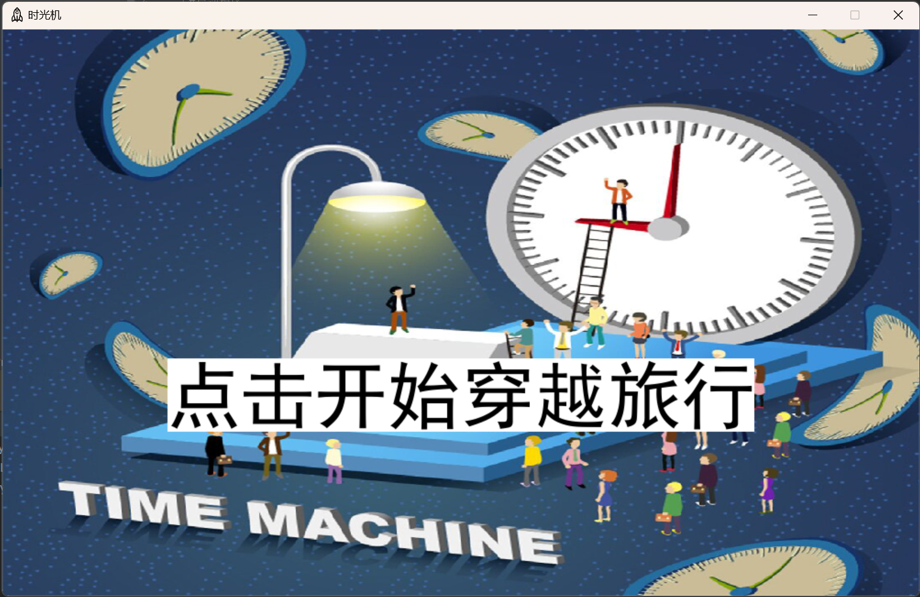

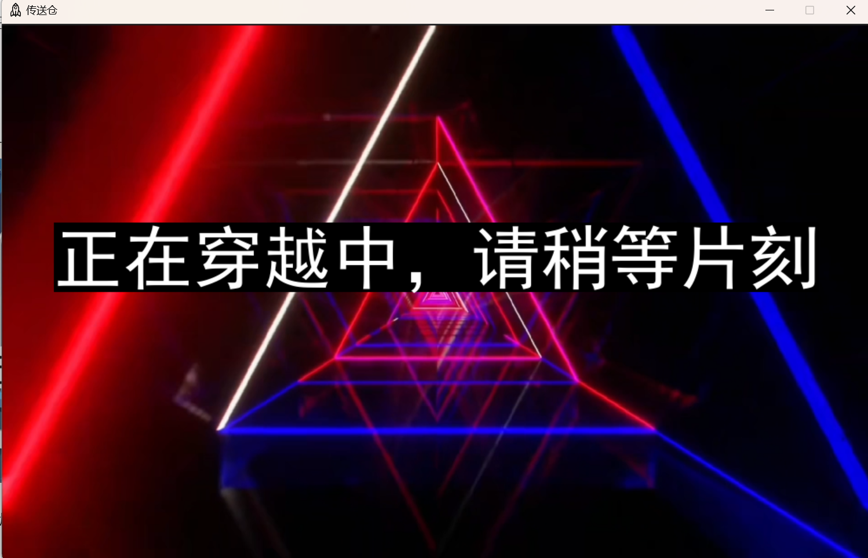

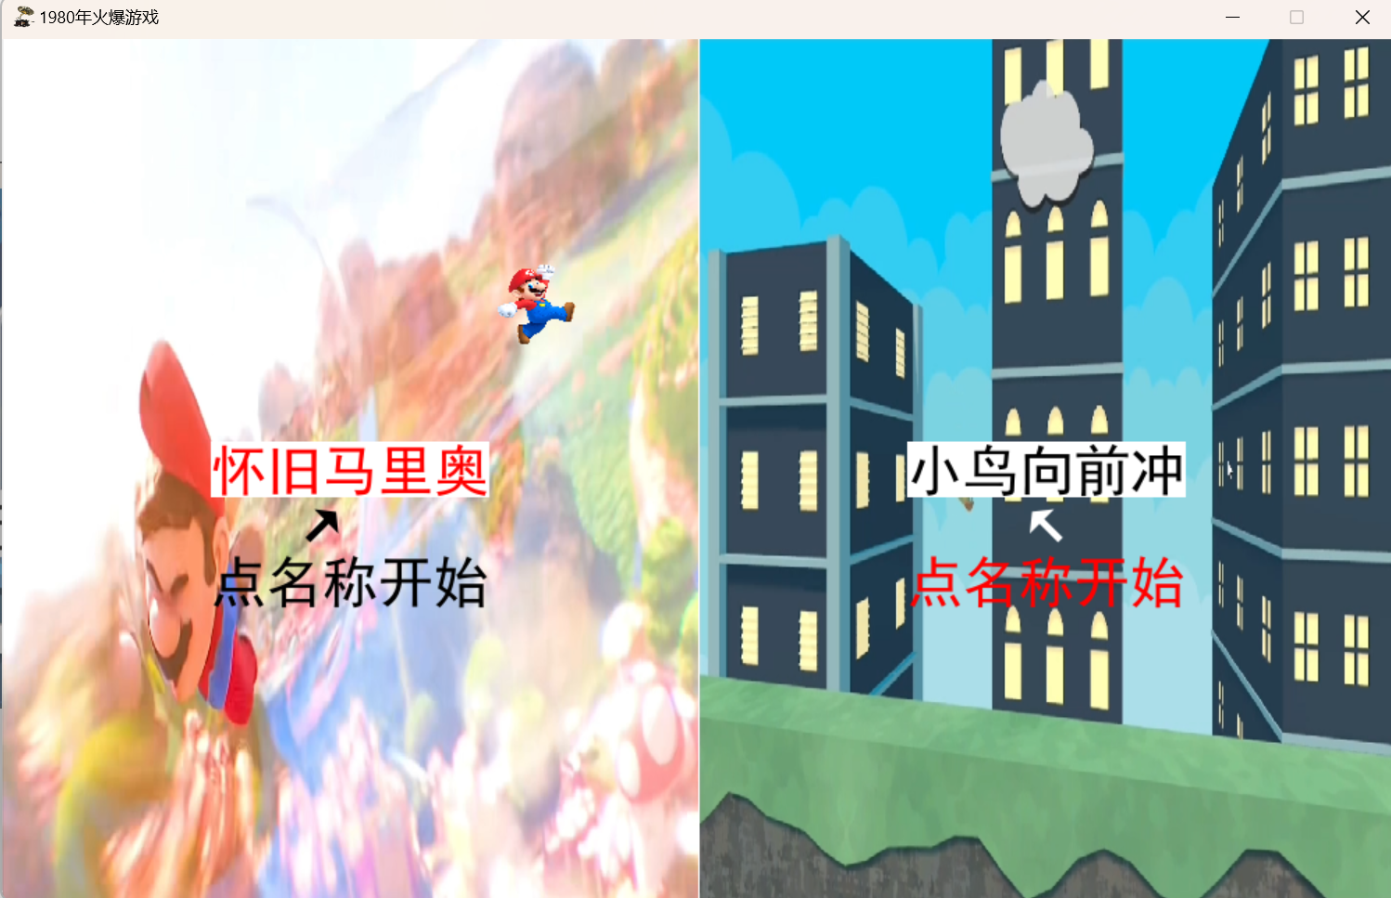

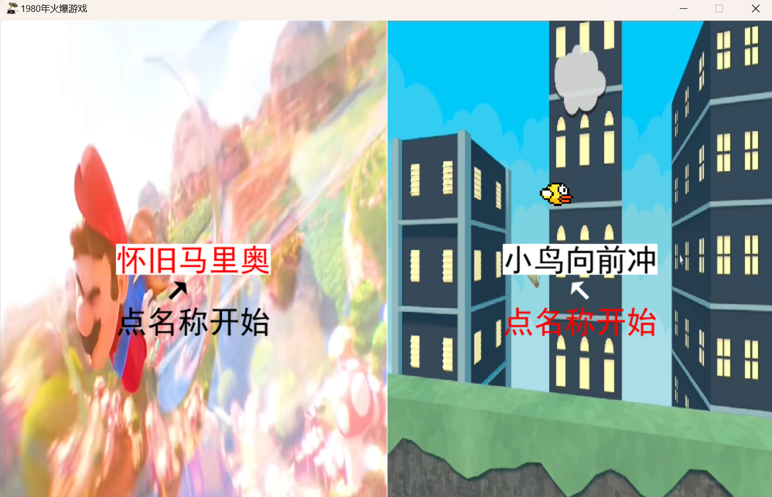

## 这是超级马里奥改编版

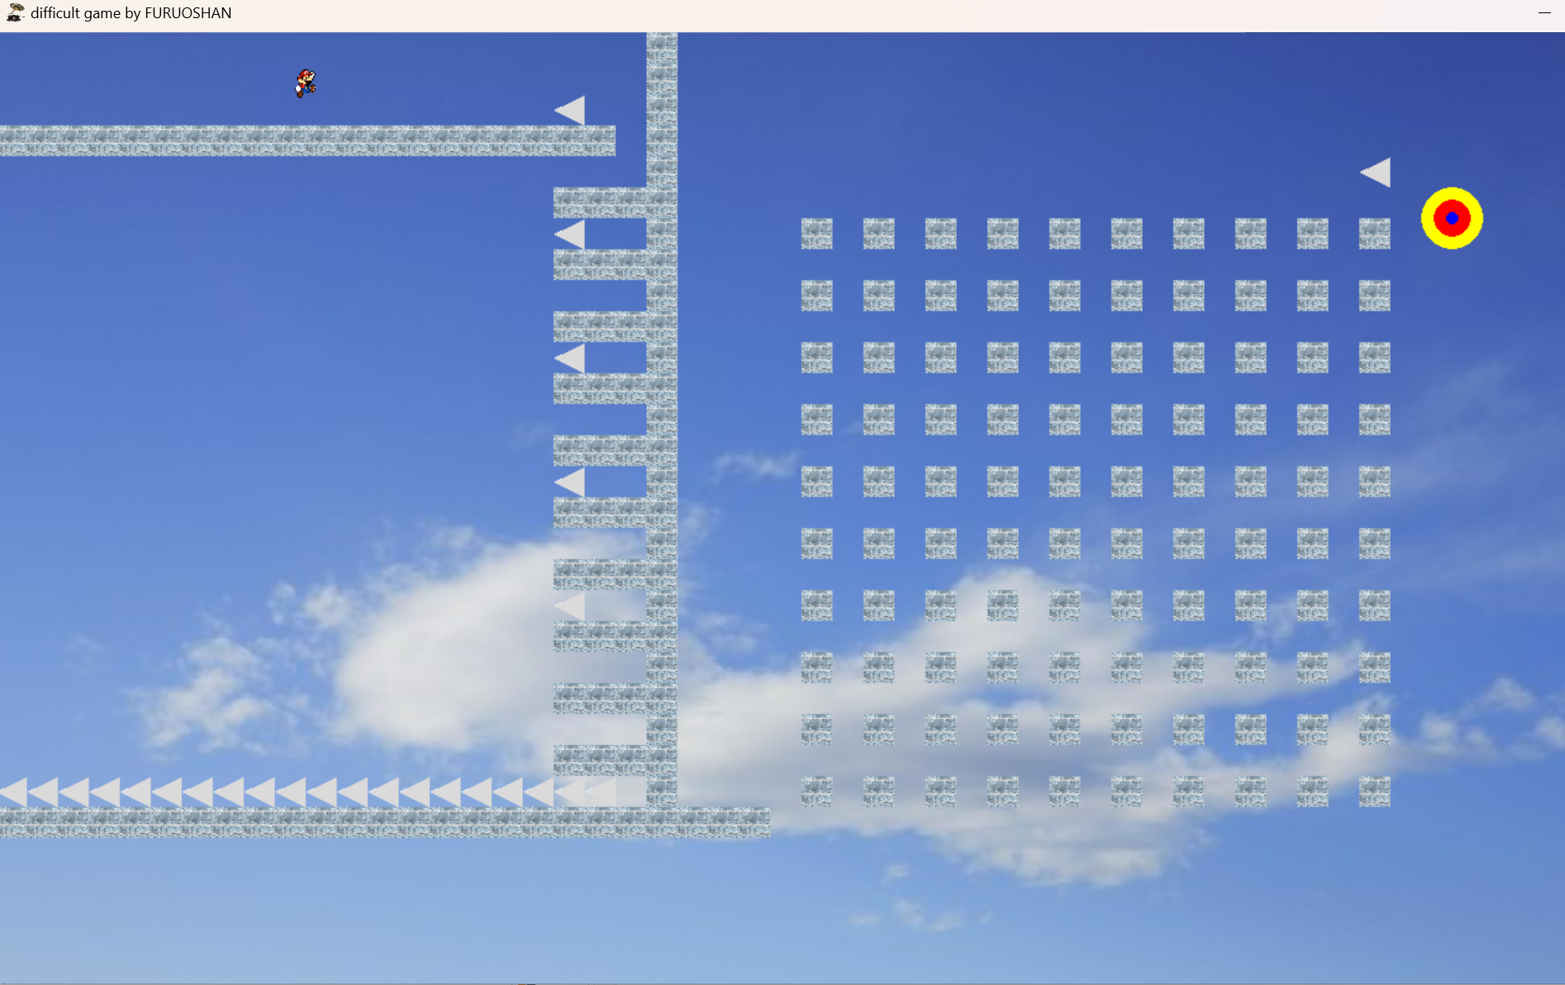

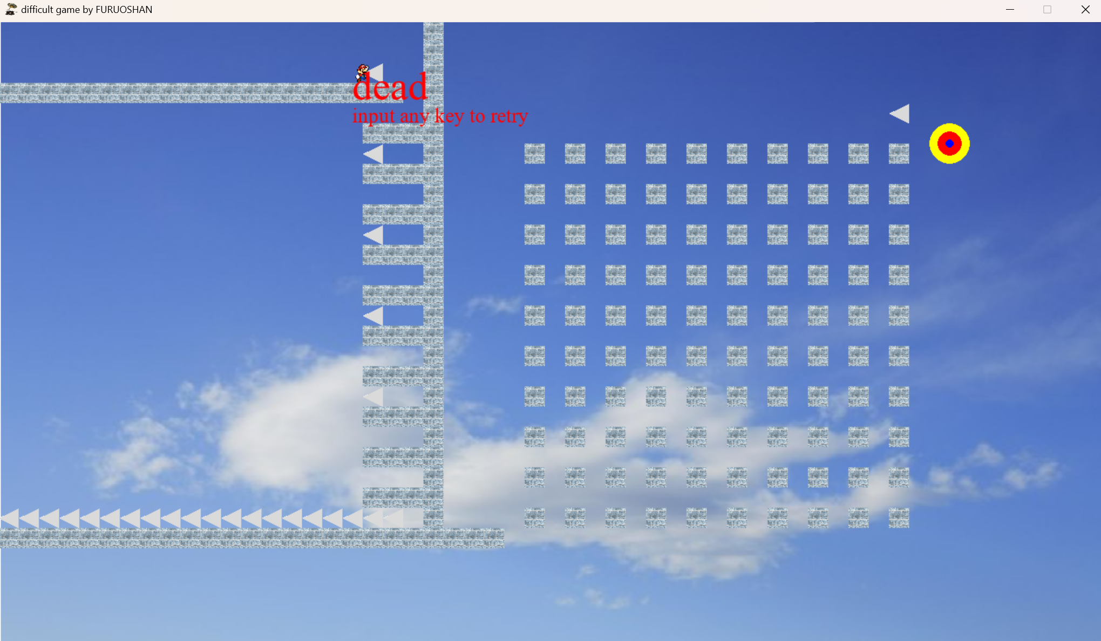

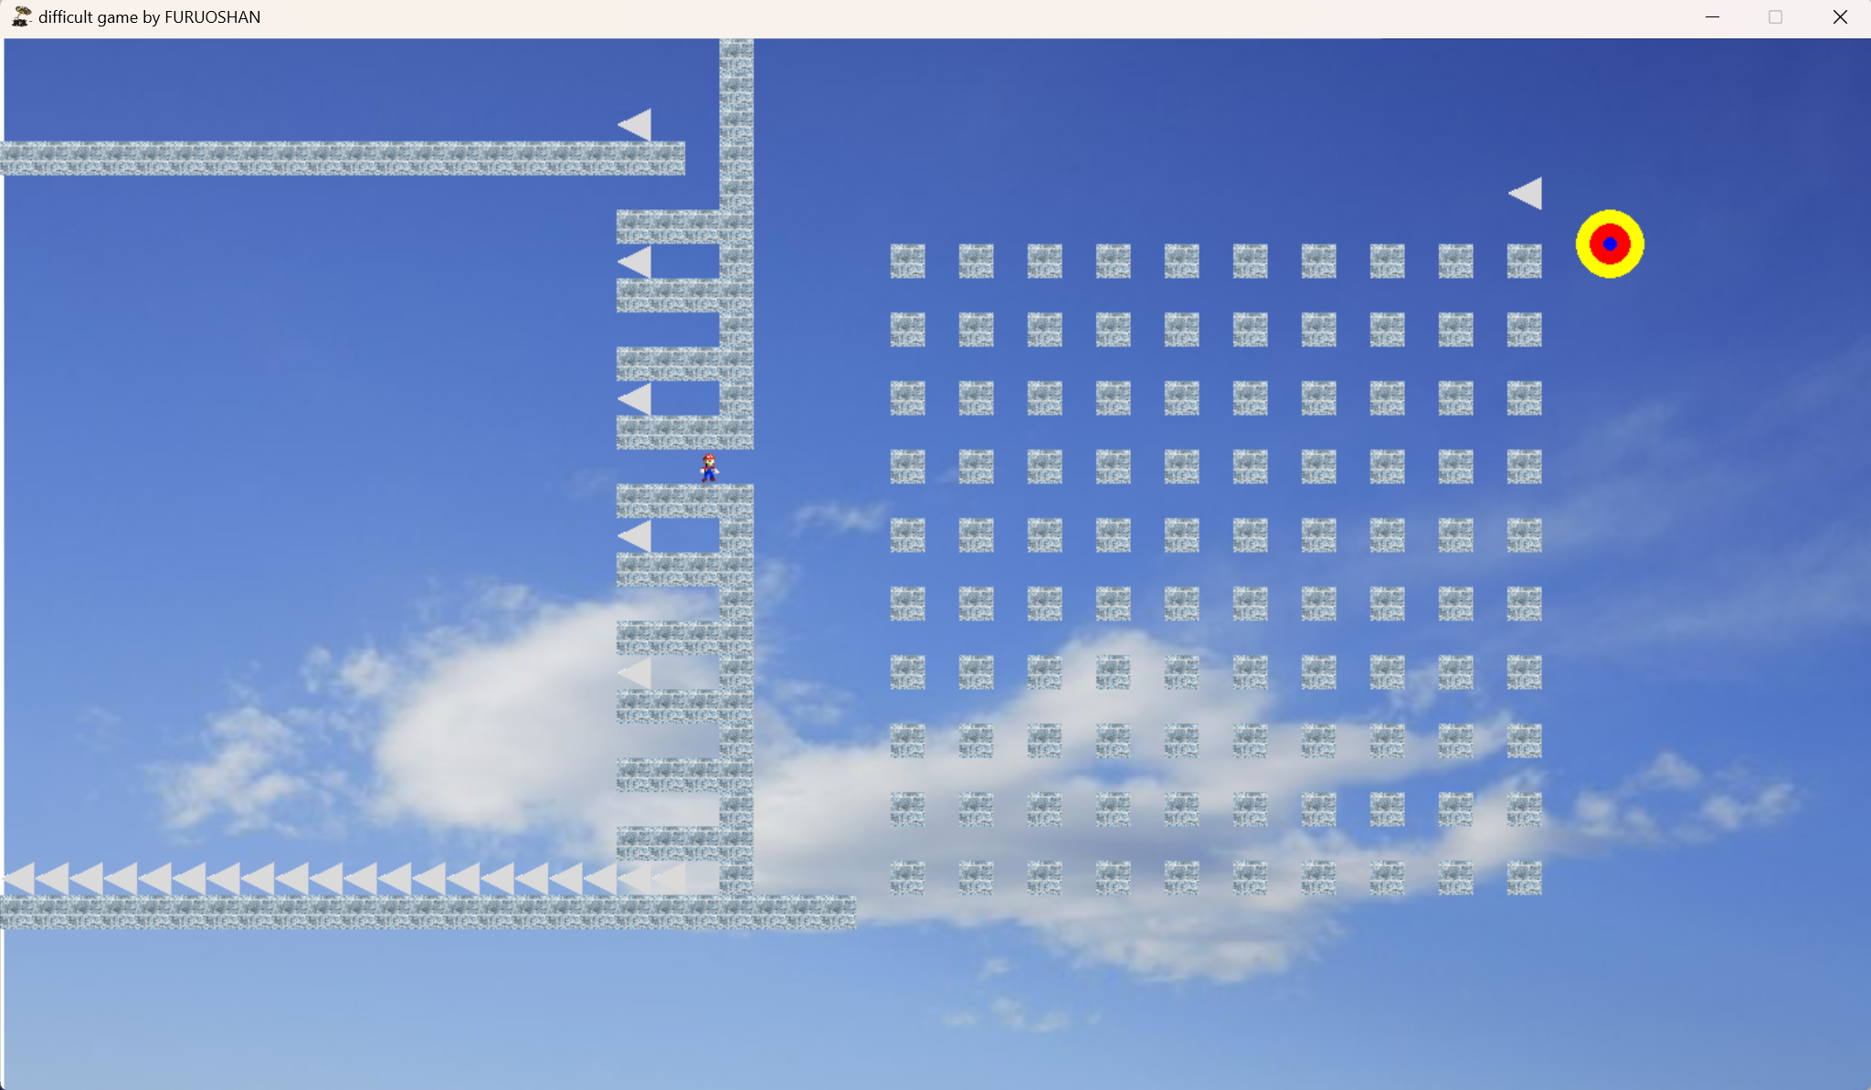

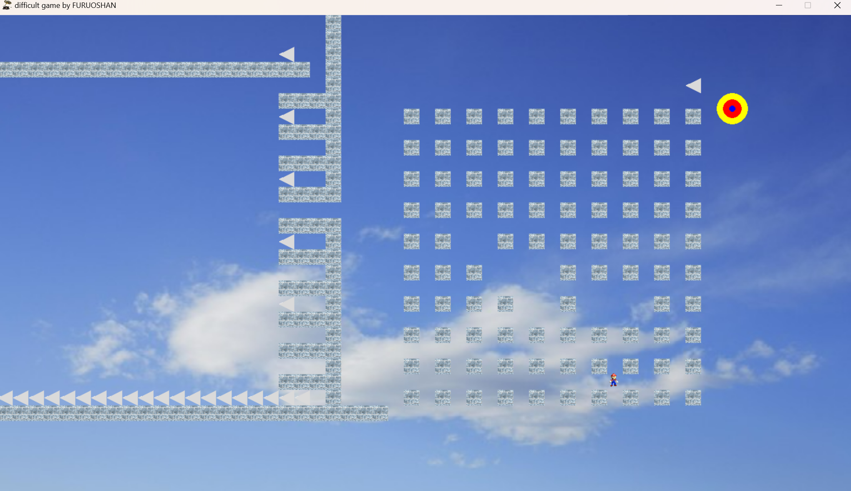

## 这是Flappy Bird的改编版

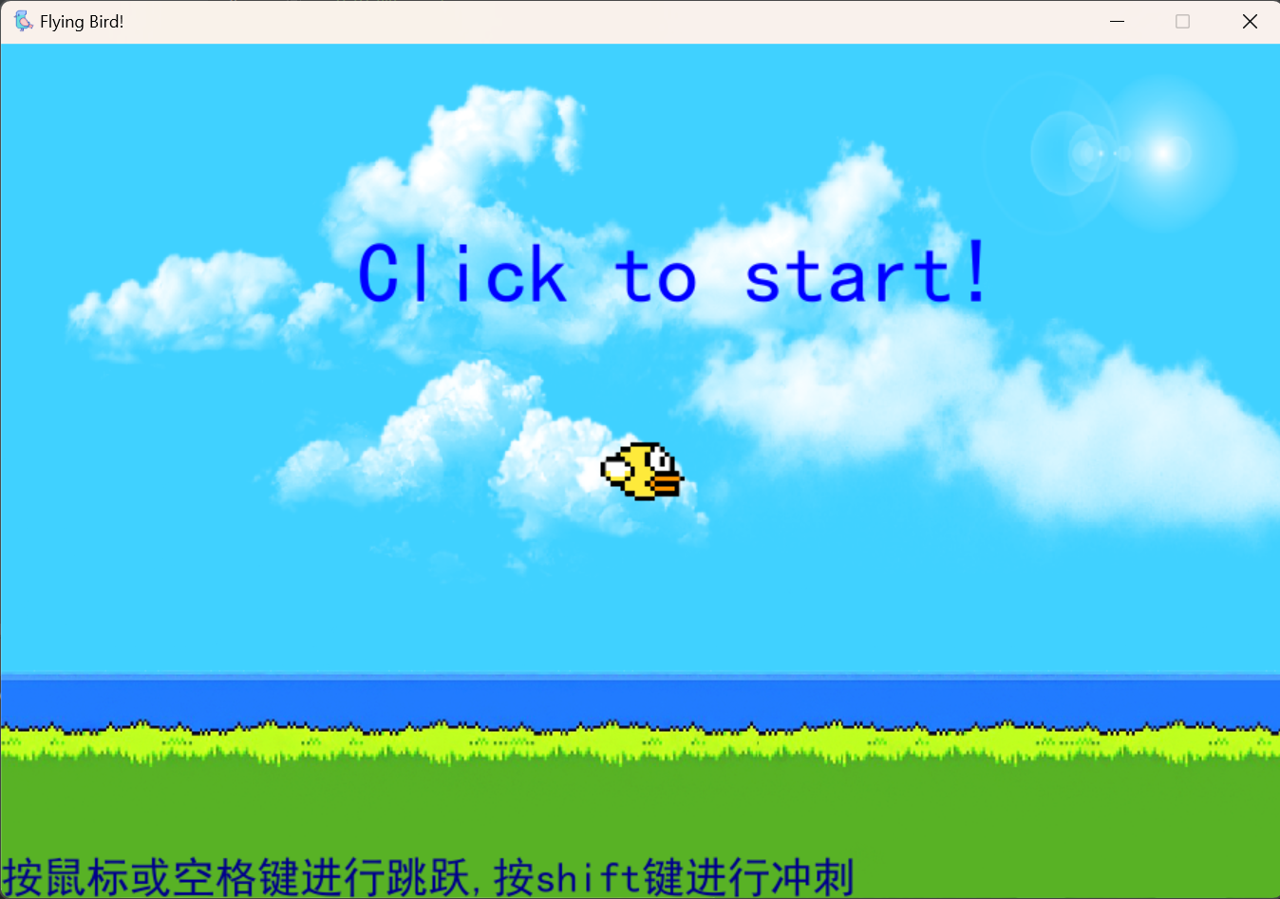

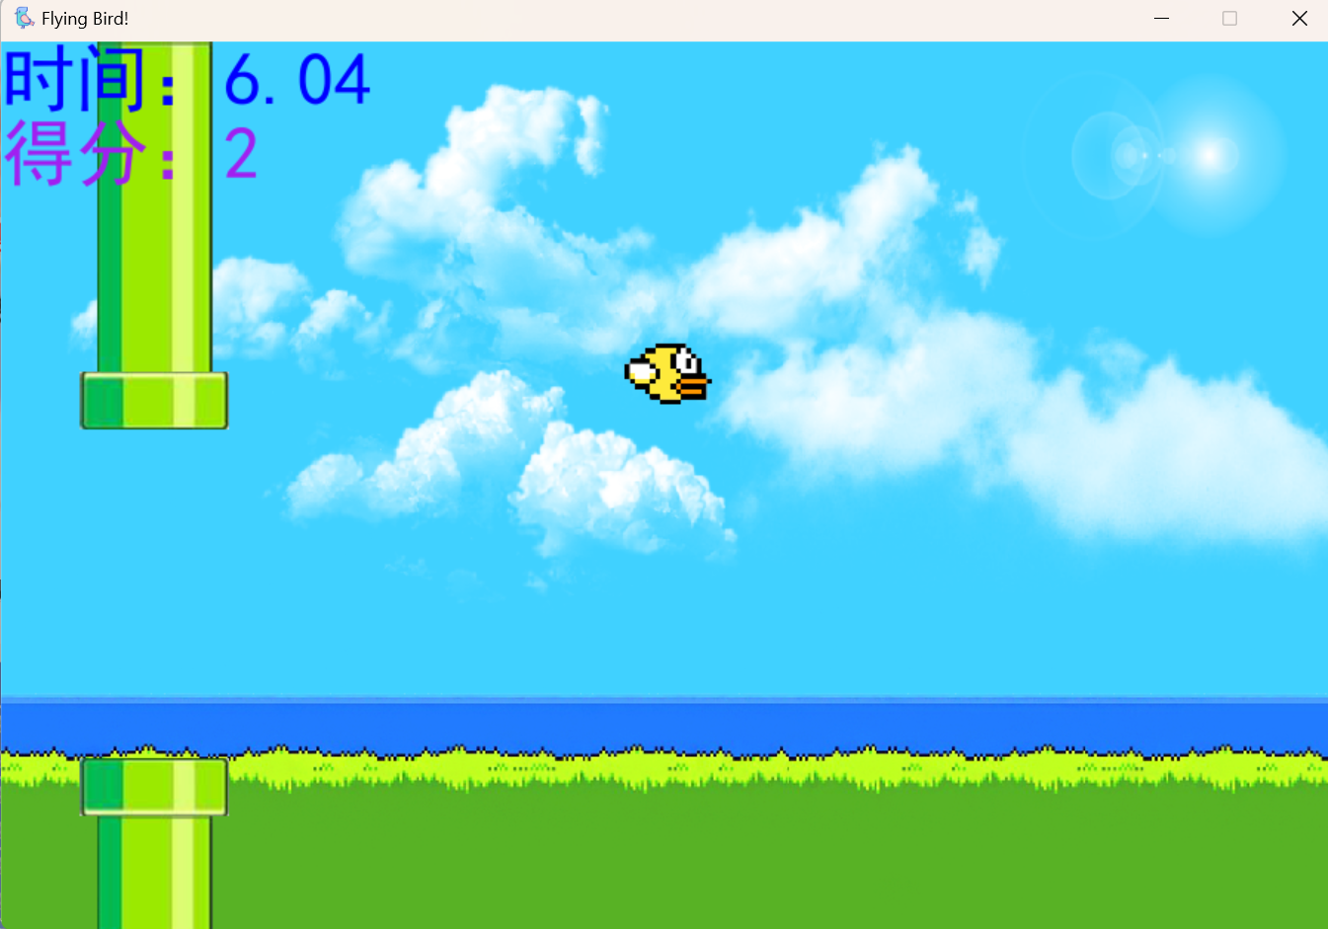

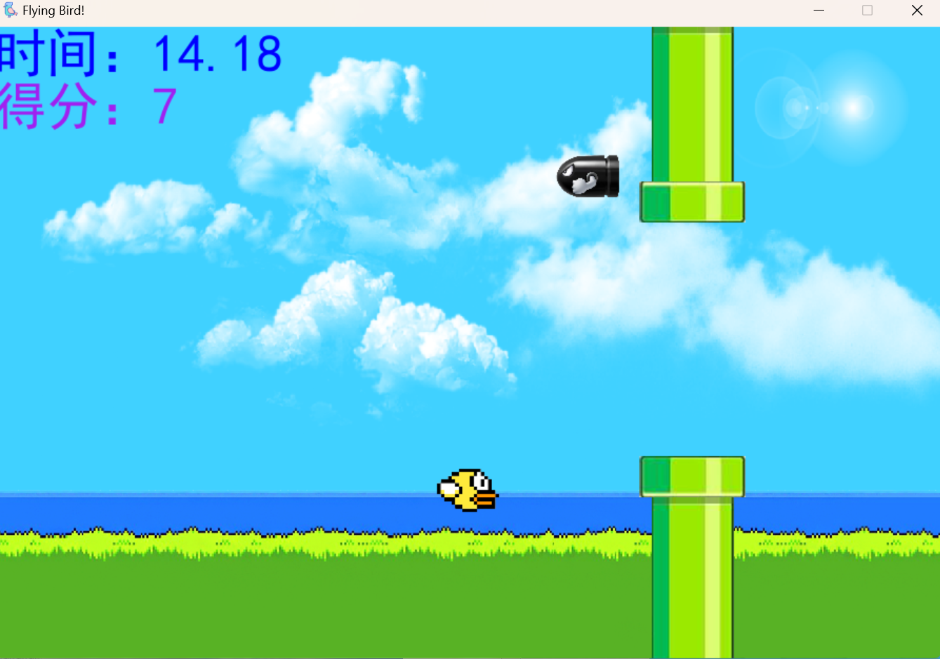

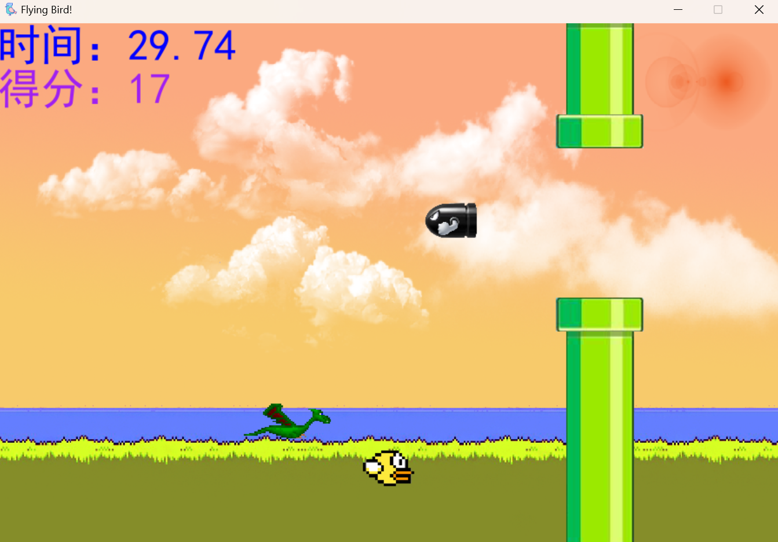

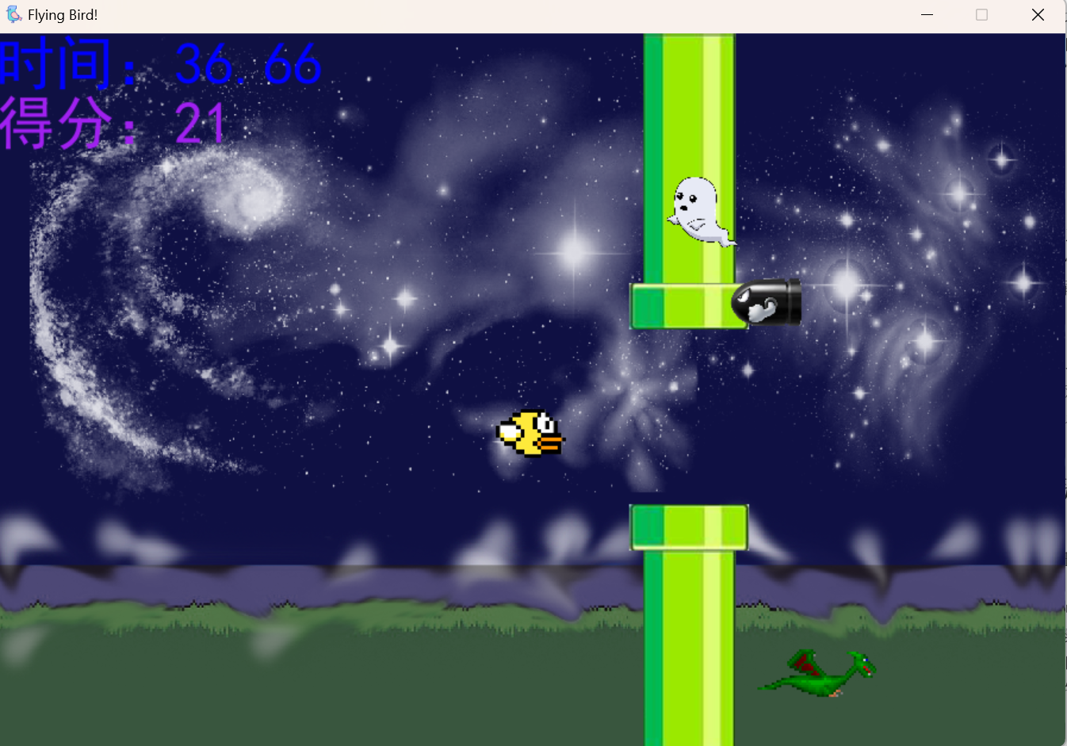

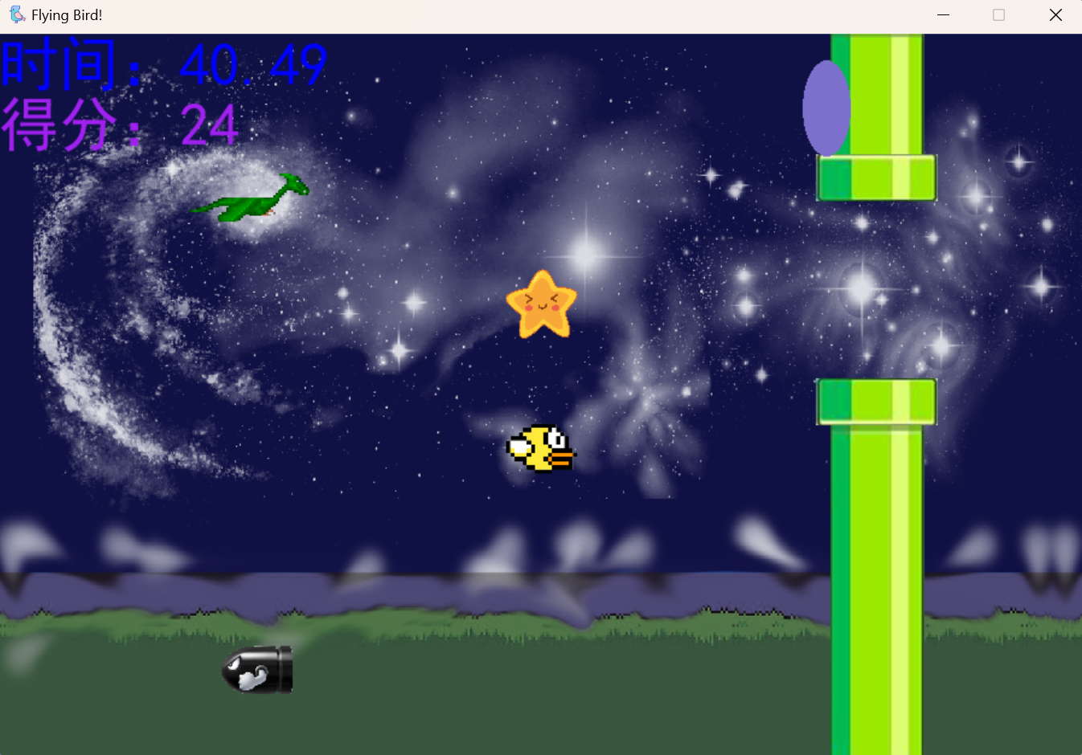

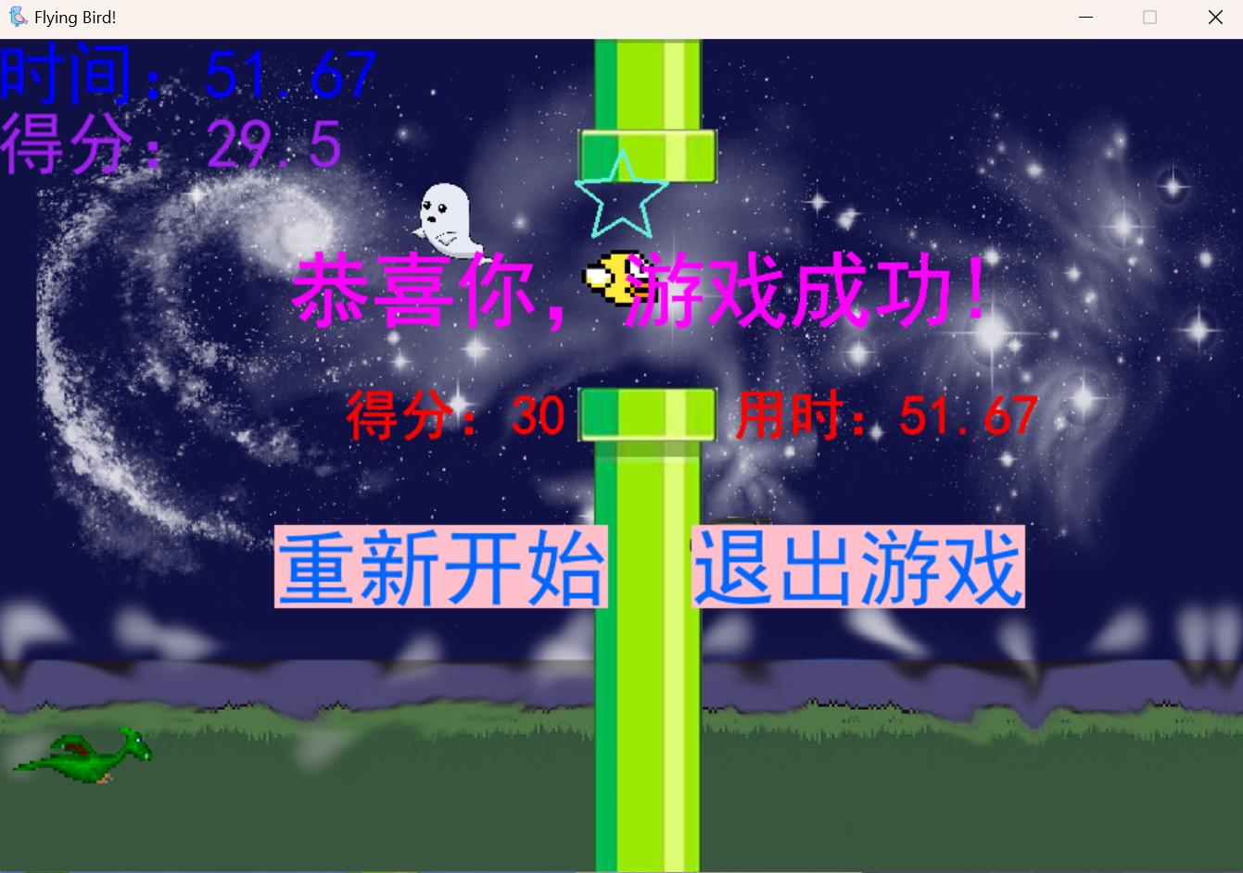

# **本系统优缺点及改进方向**

优点: 游戏中使用元素较多，如: 背景音乐、点击特效、背景图片的变换等，增加了玩家的游戏体验性，并对旧版游戏进行创新，加入了旧版游戏中不存在的新玩法。游戏的欢迎界面为玩家呈现了一个穿越到过去的场景，增加了玩家在游戏中的代入感。游戏充满像素风，适合喜爱像素风格的玩家游玩。

缺点: 游戏加载略显卡顿，玩家需要等待，可能会挫败玩家游戏积极性；在游戏中交互过快可能会导致程序崩溃自动关闭，动态背景图片的转换显得有些生硬，动态效果不好；游戏逻辑不完美，有可能出现玩家游戏失败不是因为自己操作性失误造成的而是游戏的无解情况。

改进方向：缩短加载时的卡顿时间或加载时增加新界面进行过度；优化游戏逻辑，避免游戏出现无解情况；统一游戏中动态图片的尺寸大小，使动态图片的呈现更加生动连贯；优化代码结构、避免出现游戏崩溃的情况。

# **心得体会与总结**

(收获、感想；思路、方法的总结)

心得体会：感受到了制作游戏的复杂以及学习的重要性，游戏制作需要很多环节的紧密配合才能呈现出一个好的游戏，学习则能快速掌握制作游戏某一具体环节时所需要的方法。在此游戏的创作中学会了pygame库中音乐的导入、图片的导入、界面的呈现、图片的运动、交互的实现等。

总结: 游戏的制作大体分为：构思游戏思路、设计游戏代码、实现游戏代码、游戏后期测试、代码再改进五个环节，其中实现游戏代码通常包括:交互功能的实现、音乐的加载、图片的加载、图片的变换和运动、音乐的变换。

# **对本实验问题的设计提出改进意见**

(向教师反馈实验的设计，例如，修改实验任务使得更能体现能力、水平；增加实验任务等等；所有围绕实验的建议、意见。)

将游戏纳入实验5的选题之一，并在其中附上可设计的游戏方向。介绍一些可以用于游戏制作的python第三方库，供学生参考学习，打开学生的游戏制作思路。或者给定一个统一的目标让学生实现，增强学生的问题解决能力。或者给定更多可选择的案例，拓宽学生视野，打开学生思路，提高学生对python的兴趣。

# **参考文献**

[1]blog.csdn.net

# 附件

附件清单

附件一：傅若山的源代码

附件二：苏徐涛的源代码

附件三：付文亮的源代码

# 附件

## 附件一：傅若山的源代码

(这里给出具体的内容)

import pygame  
  
  
class Background(pygame.sprite.Sprite):  
 def __init__(self, move_v: int, screen_size: ()):  
 super().__init__()  
 self.image = pygame.transform.scale(pygame.image.load("picture/background.png"), screen_size).convert()  
 self.rect = self.image.get_rect()  
 self.ground = 100  
 self.move_v = move_v  
  
 def move_left(self):  
 self.rect.x -= self.move_v  
  
 def move_right(self):  
 self.rect.x += self.move_v  
  
 def update_move_v(self, move_v: int):  
 self.move_v = move_v

import pygame  
  
  
class Brick(pygame.sprite.Sprite):  
 def __init__(self, left: int, up: int):  
 pygame.sprite.Sprite.__init__(self)  
 self.brick_size = [25, 25]  
 self.image = pygame.transform.scale(pygame.image.load("picture/brick2.png"), self.brick_size).convert()  
 self.rect = self.image.get_rect()  
 self.rect.x = left  
 self.rect.y = up  
  
  
class Bit(pygame.sprite.Sprite):  
 def __init__(self, left: int, up: int, picture: str):  
 pygame.sprite.Sprite.__init__(self)  
 self.bit_size = [25, 25]  
 self.image = pygame.transform.scale(pygame.image.load(f"picture/{picture}"), self.bit_size).convert()  
 self.image.set_colorkey((255, 255, 255))  
 self.rect = self.image.get_rect()  
 self.rect.x = left  
 self.rect.y = up  
 self.speed_x = 0  
 self.speed_y = 0  
  
 def update(self):  
 self.rect.x += self.speed_x  
 self.rect.y += self.speed_y

import pygame  
import obstacle  
  
  
class Role(pygame.sprite.Sprite):  
 def __init__(self, jump_v=3, move_v=2, g=0.20):  
 pygame.sprite.Sprite.__init__(self)  
 self.role_size = [24, 24]  
 self.picture_standing = pygame.transform.scale(pygame.image.load("picture\\person_standing.png")  
 .convert_alpha(), self.role_size)  
 self.picture_left = pygame.transform.scale(pygame.image.load("picture\\person_left.png")  
 .convert_alpha(), self.role_size)  
 self.picture_right = pygame.transform.scale(pygame.image.load("picture\\person_right.png")  
 .convert_alpha(), self.role_size)  
 self.image = self.picture_standing  
 self.rect = self.image.get_rect()  
 self.jump_v = jump_v  
 self.jump_now_v = 0  
 self.jump_times = 0  
 self.move_v = self.move_v_l = self.move_v_r = move_v  
 self.down = False  
 self.g = g  
 self.font1 = self.font2 = None  
 self.text1 = self.text2 = None  
 self.max_jump_times = 2  
 self.errors_v = 10  
 self.errors_h = 3  
 # the exact brick width is used here  
 self.cmp_const_x = (self.rect.width + 25) / 2 - self.errors_h  
 self.cmp_const_y = (self.rect.width + 25) / 2 - self.errors_v  
 self.trap_tri = [False * 10]  
  
 def move_right(self):  
 if self.rect.left >= 1361:  
 return  
 self.rect.x += self.move_v_r  
 self.image = self.picture_right  
  
 def move_left(self):  
 if self.rect.right <= 0:  
 return  
 self.rect.x -= self.move_v_l  
 self.image = self.picture_left  
  
 def drop(self):  
 self.rect.y += self.jump_now_v  
 self.jump_now_v += self.g  
  
 def lose(self):  
 self.font1 = pygame.font.SysFont("Times", 50)  
 self.text1 = self.font1.render("dead", True, (255, 0, 0))  
 self.font2 = pygame.font.SysFont("Times", 25)  
 self.text2 = self.font2.render("input any key to retry", True, (255, 0, 0))  
  
 def update(self, screen, *collide):  
 key = pygame.key.get_pressed()  
 # restore the initial value  
 self.move_v_l = self.move_v_r = self.move_v  
 self.down = True  
 if collide[0]:  
 for i in collide[0]:  
 if self.rect.top < i.rect.top < self.rect.bottom and abs(self.rect.centerx - i.rect.centerx) < \  
 self.cmp_const_x:  
 if self.jump_now_v > 0:  
 self.jump_times = 0  
 self.jump_now_v = 0  
 self.rect.bottom = i.rect.top  
 self.down = False  
 # if self.jump_now_v > 10: // die of height  
 # self.lose()  
 elif self.rect.top < i.rect.bottom < self.rect.bottom and abs(self.rect.centerx -  
 i.rect.centerx) < self.cmp_const_x:  
 if self.jump_now_v < 0:  
 self.jump_now_v = -self.jump_now_v  
  
 elif self.rect.left < i.rect.left < self.rect.right and abs(self.rect.centery -  
 i.rect.centery) < self.cmp_const_y:  
 self.move_v_r = 0  
 elif self.rect.left < i.rect.right < self.rect.right and abs(self.rect.centery -  
 i.rect.centery) < self.cmp_const_y:  
 self.move_v_l = 0  
 if self.down:  
 self.drop()  
 if self.rect.top > 768:  
 self.lose()  
 if collide[1]:  
 for i in collide[1]:  
 if pygame.sprite.collide_mask(i, self):  
 self.lose()  
 if key[pygame.K_LEFT]:  
 self.move_left()  
 elif key[pygame.K_RIGHT]:  
 self.move_right()  
 else:  
 self.image = self.picture_standing  
 screen.blit(self.image, self.rect)

*"""  
by Fu Ruoshan  
May 10th, 2023  
"""*import pygame  
from obstacle import Bit, Brick  
from background import Background  
from role import Role  
import random  
import sys  
  
brick_map1 = [[j * 25, 75] for j in range(20)]  
brick_map1.extend([[525, j * 25] for j in range(25)])  
brick_map1.extend([[450, 125 + i * 50] for i in range(10)])  
brick_map1.extend([500, 125 + i * 50] for i in range(10))  
brick_map1.extend([475, 125 + i * 50] for i in range(10))  
brick_map1.extend([[25 * i, 625] for i in range(25)])  
  
brick_map2 = [[650+50*i, 600-j*50] for i in range(10) for j in range(10)]  
  
bit_map = [[450, i*100+50] for i in range(5)]  
bit_map.append([1100, 100])  
bit_map.extend([[25*i, 600] for i in range(20)])  
bit_trap = [[0, 75], [0, 300]]  
  
  
class Game(object):  
 def __init__(self, fps: int, screen_size: ()):  
 pygame.init()  
 self.frame = fps  
 self.fps = pygame.time.Clock()  
 pygame.display.set_caption("difficult game by FURUOSHAN")  
 self.screen_size = screen_size  
 self.screen = pygame.display.set_mode(screen_size)  
 self.keep_going = True  
 self.back = Background(1, screen_size)  
 self.brick_group1 = pygame.sprite.Group()  
 self.brick_group2 = pygame.sprite.Group()  
 self.collide_with_brick = None  
 self.collide_with_bit = None  
 self.bit_group = pygame.sprite.Group()  
 self.role = Role()  
 self.pause = False  
 self.trap_tri = [False]*10  
 self.invincible = False  
 self.end = None  
  
 def update(self):  
 self.screen.blit(self.back.image, self.back.rect)  
 self.end = pygame.draw.circle(self.screen, (255, 255, 0), (1175, 150), 25)  
 pygame.draw.circle(self.screen, (255, 0, 0), (1175, 150), 15)  
 pygame.draw.circle(self.screen, (0, 0, 255), (1175, 150), 5)  
 self.brick_group1.draw(self.screen)  
 self.brick_group2.draw(self.screen)  
 self.bit_group.update()  
 self.bit_group.draw(self.screen)  
 self.collide_with_brick = pygame.sprite.spritecollide(self.role, self.brick_group1, False)  
 self.collide_with_brick.extend(pygame.sprite.spritecollide(self.role, self.brick_group2, False))  
 for i in self.collide_with_brick:  
 if i.rect.x >= 650:  
 if not random.randint(0, 20):  
 for j in self.brick_group2:  
 if j.rect == i.rect:  
 self.brick_group2.remove(j)  
 if not self.invincible:  
 self.collide_with_bit = pygame.sprite.spritecollide(self.role, self.bit_group, False)  
 self.role.update(self.screen, self.collide_with_brick, self.collide_with_bit)  
 for i in self.bit_group:  
 if 0 <= i.rect.x <= 1366 and 0 <= i.rect.y <= 768:  
 continue  
 self.bit_group.remove(i)  
 pygame.display.update()  
  
 def add_brick_group1(self, *sprite):  
 pygame.sprite.Group.add(self.brick_group1, sprite)  
  
 def add_brick_group2(self, *sprite):  
 pygame.sprite.Group.add(self.brick_group2, sprite)  
  
 def add_bit_group(self, *sprite):  
 pygame.sprite.Group.add(self.bit_group, sprite)  
  
 def creat_role(self, *pos):  
 self.role.rect.x = pos[0]  
 self.role.rect.y = pos[1]  
  
 def trap(self):  
 if self.role.rect.bottom > bit_trap[0][1]+5 and not self.trap_tri[0]:  
 self.trap_tri[0] = True  
 t = Bit(bit_trap[0][0], bit_trap[0][1], "bit_horizontal_left.png")  
 t.speed_x = 100  
 self.add_bit_group(t)  
 if self.role.rect.bottom > bit_trap[1][1]+5 and not self.trap_tri[1]:  
 self.trap_tri[1] = True  
 t = Bit(bit_trap[1][0], bit_trap[1][1]+10, "bit_horizontal_left.png")  
 t.speed_x = 100  
 self.add_bit_group(t)  
 for i in self.brick_group1:  
 if i.rect.x == 525 and i.rect.y == 300:  
 self.brick_group1.remove(i)  
 break  
  
 def if_win(self):  
 if 1150 < self.role.rect.x < 1200 and 125 < self.role.rect.y < 175:  
 return True  
 return False  
  
def init():  
 game1 = Game(60, (1366, 768))  
 game1.add_brick_group1(Brick(i[0], i[1]) for i in brick_map1)  
 game1.add_brick_group2(Brick(i[0], i[1]) for i in brick_map2)  
 game1.add_bit_group(Bit(i[0], i[1], "bit_horizontal_left.png") for i in bit_map)  
 game1.creat_role(25, 25)  
 pygame.mixer.music.load("music2/jump.wav")  
 pygame.mixer.music.set_volume(0.2)  
 return game1  
  
  
game = init()  
pygame.init()  
flag = False  
while game.keep_going:  
 game.fps.tick(game.frame)  
 game.trap()  
 for event in pygame.event.get():  
 if event.type == pygame.QUIT or (event.type == pygame.KEYDOWN and event.key == pygame.K_ESCAPE):  
 game.keep_going = False  
 elif event.type == pygame.KEYDOWN:  
 if event.key == pygame.K_SPACE and game.role.jump_times < game.role.max_jump_times:  
 game.role.jump_now_v = -game.role.jump_v  
 game.role.jump_times += 1  
 pygame.mixer.music.play()  
 # invincible mode  
 if pygame.key.get_pressed()[pygame.K_TAB]:  
 game.invincible = True  
 else:  
 game.invincible = False  
 game.update()  
 if game.if_win():  
 font1 = pygame.font.SysFont("Times", 50)  
 text1 = font1.render("YOU WIN", True, (255, 0, 0))  
 game.screen.blit(text1, game.role.rect)  
 pygame.display.update()  
 flag = True  
 while flag:  
 for event in pygame.event.get():  
 if (event.type == pygame.KEYDOWN and event.key == pygame.K_ESCAPE) or event.type == pygame.QUIT:  
 flag = False  
 game.keep_going = False  
 break  
 if game.role.text1:  
 if game.role.rect.left < 0:  
 game.role.rect.left = 0  
 if game.role.rect.right > 1100:  
 game.role.rect.right = 1100  
 if game.role.rect.top < 0:  
 game.role.rect.top = 0  
 if game.role.rect.bottom > 650:  
 game.role.rect.bottom = 650  
 game.screen.blit(game.role.text1, game.role.rect)  
 game.screen.blit(game.role.text2, (game.role.rect.x, game.role.rect.y + 50))  
 pygame.display.update()  
 flag = True  
 while flag:  
 for event in pygame.event.get():  
 if event.type == pygame.KEYDOWN:  
 flag = False  
 game = init()  
 break  
 elif event.type == pygame.QUIT:  
 game.keep_going = False  
 flag = False  
 break  
pygame.quit()  
sys.exit()

## 附件二：苏徐涛的源代码

(这里给出具体的内容)

*'''  
Content:Flying Bird Game  
Author:苏徐涛  
'''*import sys  
import time  
import pygame  
# 窗口大小  
width=900;height=600  
from Class import *  
size=(width,height)  
chang=600;gao=300  
da_xiao=(chang,gao)  
def UpdateMap():  
 *'''  
 展示小鸟、管道、怪物、背景  
 '''* # 三个阶段  
 if Bird.score//10==0 or Pipeline1.isappear:  
 screen.blit(background1,(0,0))  
  
 # 显示上管道  
 screen.blit(Pipeline1.guandao_up, (Pipeline1.x, Pipeline1.up_guandao))  
 screen.blit(Pipeline1.guankou_up, (Pipeline1.x - 12, Pipeline1.up_guankou))  
 # 显示下管道  
 screen.blit(Pipeline1.guandao_down, (Pipeline1.x, Pipeline1.down_guandao))  
 screen.blit(Pipeline1.guankou_down, (Pipeline1.x - 12, Pipeline1.down_guankou))  
 Pipeline1.appear()  
  
 if Pipeline1.x == Bird.x:  
 Bird.score += 1  
  
 elif Bird.score//10==1 or Pipeline2.isappear:  
 screen.blit(background2,(0,0))  
  
 # 显示上管道  
 screen.blit(Pipeline2.guandao_up, (Pipeline2.x, Pipeline2.up_guandao))  
 screen.blit(Pipeline2.guankou_up, (Pipeline2.x - 12, Pipeline2.up_guankou))  
 # 显示下管道  
 screen.blit(Pipeline2.guandao_down, (Pipeline2.x, Pipeline2.down_guandao))  
 screen.blit(Pipeline2.guankou_down, (Pipeline2.x - 12, Pipeline2.down_guankou))  
 Pipeline2.appear()  
  
 if Pipeline2.x == Bird.x:  
 Bird.score += 1  
  
 elif Bird.score//10==2:  
 if Bird.score==20 and Status.music!=-2:  
 Status.music=2  
 music()  
 screen.blit(background3,(0,0))  
 # 显示上管道  
 screen.blit(Pipeline3.guandao_up, (Pipeline3.x, Pipeline3.up_guandao))  
 screen.blit(Pipeline3.guankou_up, (Pipeline3.x - 12, Pipeline3.up_guankou))  
 # 显示下管道  
 screen.blit(Pipeline3.guandao_down, (Pipeline3.x, Pipeline3.down_guandao))  
 screen.blit(Pipeline3.guankou_down, (Pipeline3.x - 12, Pipeline3.down_guankou))  
 Pipeline3.appear()  
  
 if Pipeline3.x == Bird.x and Bird.score >= 28:  
 Bird.score += 0.5  
 elif Pipeline3.x == Bird.x:  
 Bird.score += 1  
  
 # 显示怪物  
 if Bird.score>5:  
 Shell1.appear(screen,Pipeline1.empty)  
 if Bird.score>10:  
 Shell2.appear(screen,Pipeline2.empty)  
 if Bird.score>15:  
 Shell2.disappear()  
 Dragon.appear(screen,Pipeline2.empty)  
 if Bird.score>20:  
 Ghost.appear(screen,Pipeline3.empty)  
 if Bird.score>22:  
 Star.appear(screen,Pipeline3.empty)  
 # 公布得分和时间  
 screen.blit(time_text,(0,0))  
 screen.blit(score_text,(0,50))  
  
 if Bird.score==10 and Pipeline1.x<=-80:  
 Pipeline1.disappear()  
 if Bird.score==20 and Pipeline2.x<=-80:  
 Pipeline2.disappear()  
  
 if Bird.dead:  
 Bird.status=2  
 elif Bird.jump:  
 Bird.status=1  
  
 Status.Bird=(Bird.x,Bird.y)  
 screen.blit(Image_bird,Status.Bird)  
 Bird.up_down()  
  
def CheckDead():  
 *'''  
 检测小鸟是否死亡  
 '''* if Bird.y < -40 or Bird.y > 600:  
 Bird.dead = True  
 if Status.ctrl:  
 return 0  
 # 检测怪物  
 Rect=Shell1.Rect,Shell2.Rect,Dragon.Rect,Ghost.Rect,Star.Rect  
 for i in range(len(Rect)):  
 if Bird.birdRect.colliderect(Rect[i]) and i<3:  
 Bird.dead=True  
 if Bird.birdRect.colliderect(Rect[i]) and i==3 and Ghost.coll==True:  
 Bird.dead=True  
 if Bird.birdRect.colliderect(Rect[i]) and i==4 and Star.coll==True:  
 Bird.dead=True  
 # 检测管道  
 rect=Pipeline1.guandao_up_Rect,Pipeline1.guankou_up_Rect,Pipeline1.guandao_down_Rect,Pipeline1.guankou_down_Rect,Pipeline2.guandao_up_Rect,Pipeline2.guankou_up_Rect,Pipeline2.guandao_down_Rect,Pipeline2.guankou_down_Rect,Pipeline3.guandao_up_Rect,Pipeline3.guankou_up_Rect,Pipeline3.guandao_down_Rect,Pipeline3.guankou_down_Rect  
 for i in range(len(rect)):  
 if Bird.birdRect.colliderect(rect[i]):  
 Bird.dead=True  
 # 小鸟死亡后换遗像  
 if Bird.dead==True:  
 screen.blit(Image_bird_dead, Status.Bird)  
  
def music():  
 if Status.music == 1:  
 Status.music = -1  
 music_begin.stop()  
 music_pos1.set_volume(0.3)  
 music_pos1.play()  
 elif Status.music == 2:  
 Status.music = -2  
 music_pos1.stop()  
 music_pos2.set_volume(0.3)  
 music_pos2.play()  
 elif Status.music == 3:  
 Status.music = -3  
 music_pos2.stop()  
 music_victory.set_volume(0.3)  
 music_victory.play()  
 elif Status.music == 4:  
 Status.music = -4  
 music_pos1.stop()  
 music_pos2.stop()  
 music_failure.set_volume(0.3)  
 music_failure.play()  
 elif Status.music == 5:  
 Status.music=1  
 music_failure.stop()  
 music_victory.stop()  
  
  
  
  
 # 初始化设置，窗口大小，标题，图标展示  
pygame.init()  
screen=pygame.display.set_mode(size)  
pygame.display.set_caption('Flying Bird!')  
ico=pygame.image.load('image/Bird_ico.png')  
pygame.display.set_icon(ico)  
clock=pygame.time.Clock()  
 # 类的初始化  
Status=Status()  
Bird=Bird()  
Pipeline1=Pipeline1()  
Pipeline2=Pipeline2()  
Pipeline3=Pipeline3()  
Dragon=Dragon()  
Shell1=Shell()  
Shell2=Shell()  
Ghost=Ghost()  
Star=Star()  
  
 # 背景图片  
background1=pygame.image.load('image/background1.png').convert_alpha()  
background1=pygame.transform.scale(background1,size)  
background2 = pygame.image.load('image/background2.png').convert_alpha()  
background2 = pygame.transform.scale(background2, size)  
background3 = pygame.image.load('image/background3.png').convert_alpha()  
background3 = pygame.transform.scale(background3, size)  
  
 # 鸟的图片  
bird_size=Bird.size  
Image_bird=pygame.image.load('image/Bird.png').convert_alpha()  
Image_bird=pygame.transform.scale(Image_bird,(bird_size,bird_size))  
Image_bird_dead=pygame.image.load('image/DeadBird.png').convert_alpha()  
Image_bird_dead=pygame.transform.scale(Image_bird_dead,(bird_size,bird_size))  
  
 # 音乐  
channel=pygame.mixer.find_channel(True)  
channel_jump=pygame.mixer.find_channel(True)  
channel_jump.set_volume(0.2)  
music_begin=pygame.mixer.Sound('music/助手.mp3')  
music_pos1=pygame.mixer.Sound('music/询问2.mp3')  
music_pos2=pygame.mixer.Sound('music/询问2+.mp3')  
music_victory=pygame.mixer.Sound('music/胜诉3.mp3')  
music_failure=pygame.mixer.Sound('music/真相的苦涩味.mp3')  
music_jump=pygame.mixer.Sound('music/jump.wav')  
channel.play(music_begin)  
  
 # 字体和文本  
start_font=pygame.font.SysFont('SimHei', 60)  
start_text=start_font.render('Click to start!', True, 'blue')  
info_font=pygame.font.SysFont('SimHei',30)  
info_text=info_font.render('''按鼠标或空格键进行跳跃,按shift键进行冲刺''',True,'darkblue')  
score_font=pygame.font.SysFont('SimHei',50)  
time_font = pygame.font.SysFont('SimHei', 50)  
settle_font=pygame.font.SysFont('SimHei',60)  
settle_font2=pygame.font.SysFont('SimHei',40)  
choice_font=pygame.font.SysFont('SimHei',60)  
  
 # 游戏主体  
while 1:  
 clock.tick(60)  
 if Status.status==4:  
 # 重新开始  
 Status.__init__()  
 Bird.__init__()  
 Pipeline1.__init__()  
 Pipeline2.__init__()  
 Pipeline3.__init__()  
 Ghost.__init__()  
 Shell1.__init__()  
 Shell2.__init__()  
 Star.__init__()  
 Dragon.__init__()  
 music_victory.stop()  
 music_failure.stop()  
 channel.set_volume(0.3)  
 channel.play(music_begin)  
 continue  
 if Bird.dead:  
 time.sleep(1)  
 Status.status=2  
 if Bird.score==30:  
 if Status.music == -2:  
 Status.music=3  
 music()  
 Status.status=1  
 time.sleep(0.5)  
 # 键盘，鼠标轮询  
 for event in pygame.event.get():  
 if event.type==pygame.QUIT:  
 pygame.quit()  
 sys.exit()  
 if event.type==pygame.MOUSEBUTTONDOWN and not Status.begin:  
 Status.music=1  
 music()  
 Status.begin = 1  
 start_time=time.time()  
 if (event.type ==pygame.MOUSEBUTTONDOWN or event.type==pygame.KEYDOWN and event.key==pygame.K_SPACE) and not Bird.dead and Status.begin:  
 Bird.jump=True  
 Bird.g=2  
 Bird.a=10  
 music_jump.set_volume(0.3)  
 music_jump.play()  
 if event.type==pygame.KEYDOWN and (event.key==pygame.K_LSHIFT or event.key==pygame.K_RSHIFT):  
 Status.shift=True  
 if event.type==pygame.KEYUP and (event.key==pygame.K_LSHIFT or event.key==pygame.K_RSHIFT):  
 Status.shift=False  
 if event.type==pygame.KEYDOWN and (event.key==pygame.K_LCTRL or event.key==pygame.K_RCTRL):  
 Status.ctrl=True  
 if event.type==pygame.KEYUP and (event.key==pygame.K_LCTRL or event.key==pygame.K_RCTRL):  
 Status.ctrl=False  
 if event.type==pygame.MOUSEBUTTONDOWN and Status.status in (1,2):  
 mouse_x,mouse_y=event.pos  
 if mouse_x > width / 2 - chang / 2+50 and mouse_x<width / 2 - chang / 2+290 and mouse_y>350 and mouse_y<410:  
 Status.status=4  
 if mouse_x > width / 2 - chang / 2+350 and mouse_x<width / 2 - chang / 2+590 and mouse_y>350 and mouse_y<410:  
 pygame.quit()  
 sys.exit()  
  
 # 按shift实现冲刺，按ctrl实现无敌  
 if Status.shift:  
 Pipeline1.v = 10  
 Pipeline2.v = 10  
 Pipeline3.v = 10  
 Ghost.v = 12  
 Shell1.v = 12  
 Shell2.v = 12  
 Dragon.v = -2  
 else:  
 Pipeline1.v = 5  
 Pipeline2.v = 5  
 Pipeline3.v = 5  
 Ghost.v = 7  
 Shell1.v = 7  
 Shell2.v = 7  
 Dragon.v = -7  
  
 # 其他事件  
 if Status.status==0:  
 if Status.begin:  
 score_text = score_font.render(f'得分：{Bird.score}', True, 'purple')  
 Status.time=time.time()-start_time  
 time_text = time_font.render('时间：%.2f' % (Status.time), True, 'blue')  
 UpdateMap()  
 CheckDead()  
 else:  
 screen.blit(background1,(0,0))  
 screen.blit(start_text, (250, 130))  
 screen.blit(info_text,(0,570))  
 screen.blit(Image_bird, (width / 2 - bird_size / 2, height / 2 - bird_size / 2))  
 elif Status.status==1:  
 settle_text1 = settle_font.render('恭喜你，游戏成功! ', True, 'magenta')  
 settle_text2 = settle_font2.render('得分：%d 用时：%.2f' % (Bird.score, Status.time), True, 'red')  
 choice_text1 = choice_font.render('重新开始', True, '#0066ff', 'pink')  
 choice_text2 = choice_font.render('退出游戏', True, '#0066ff', 'pink')  
 screen.blit(settle_text1, (width / 2 - chang / 2 + 60, height / 2 - gao / 2))  
 screen.blit(settle_text2, (width / 2 - chang / 2 + 100, height / 2 - gao / 2 + 100))  
 screen.blit(choice_text1, (width / 2 - chang / 2 + 50, 350))  
 screen.blit(choice_text2, (width / 2 - chang / 2 + 350, 350))  
 elif Status.status==2:  
 if Status.music in (-1,-2) and Status.music!=-4:  
 Status.music=4  
 music()  
 settle_text1 = settle_font.render('很遗憾，游戏失败! ', True, 'black')  
 settle_text2 = settle_font2.render('得分：%d 用时：%.2f' % (Bird.score, Status.time), True, 'darkblue')  
 choice_text1=choice_font.render('重新开始',True,'#000033','#99ff99')  
 choice_text2=choice_font.render('退出游戏',True,'#000033','#99ff99')  
 screen.blit(settle_text1, (width / 2 - chang / 2+60, height / 2 - gao / 2))  
 screen.blit(settle_text2, (width / 2 - chang / 2+100, height / 2 - gao / 2 + 100))  
 screen.blit(choice_text1, (width / 2 - chang / 2+50,350))  
 screen.blit(choice_text2, (width / 2 - chang / 2+350,350))  
  
 pygame.display.flip()

*'''  
Content:Classes and Methods  
Author:苏徐涛  
'''*import random  
import math  
import time  
import pygame  
from game2 import width,height  
  
class Status:  
 *'''  
 定义游戏状态  
 '''* def __init__(self):  
 self.begin=False  
 self.shift=False  
 self.status=0 # 0表示游戏中，1表示胜利，2表示失败，3表示退出，4表示重开  
 self.time=0  
 self.music=1 # 1表示进程1，2表示进程2，3表示胜利，4表示失败，5表示重开  
 self.Bird=0 #  
 self.ctrl=False  
class Bird:  
 *'''  
 定义飞行的小鸟  
 '''* def __init__(self):  
 self.birdStatus=[pygame.image.load('image/Bird.png').convert_alpha(),pygame.image.load('image/Bird.png').convert_alpha(),pygame.image.load('image/Bird.png').convert_alpha()]  
 self.dead=False  
 self.jump=False  
 self.g=2  
 self.a=10  
 self.size=60  
 self.x=width/2-self.size/2  
 self.y=height/2-self.size/2  
 self.score=0  
 self.status=0  
 self.birdRect=pygame.Rect(self.x+self.size/6,self.y+self.size/6,self.size*2/3,self.size*2/3)  
  
 def up_down(self):  
 if self.jump:  
 self.a-=0.8  
 self.y-=self.a  
 else:  
 self.g+=0.05  
 self.y+=self.g  
 self.birdRect[1]=self.y+self.size/6  
  
  
class Pipeline:  
 *'''  
 定义得分关键的管道,同时也是不同管道的基类  
 '''* def __init__(self):  
 # 管道图片  
 self.guandao_up=pygame.image.load('image/管道.png').convert_alpha()  
 self.guandao_down=pygame.image.load('image/管道.png').convert_alpha()  
 self.guankou_up=pygame.image.load('image/上管口.png').convert_alpha()  
 self.guankou_down=pygame.image.load('image/下管口.png').convert_alpha()  
 self.x=900  
 self.v=5  
 self.isappear=True  
 self.size_guandao=self.guandao_up.get_height(),self.guandao_down.get_height()  
 self.size_guankou=self.guankou_up.get_height()  
 # 管道位置  
 self.up_guandao=0  
 self.up_guankou=self.size_guandao[0]  
 self.down_guandao=height-self.size_guandao[1]  
 self.down_guankou=self.down_guandao-self.size_guankou  
 self.empty=(self.size_guankou+self.size_guandao[0],self.down_guankou)  
 # 碰撞检测矩形  
 self.guandao_up_Rect = pygame.Rect(self.x,self.up_guandao,self.guandao_up.get_width(),self.size_guandao[0])  
 self.guandao_down_Rect = pygame.Rect(self.x,self.down_guandao,self.guandao_down.get_width(),self.size_guandao[1])  
 self.guankou_up_Rect = pygame.Rect(self.x-12,self.up_guankou-5,self.guankou_up.get_width(),self.size_guankou-5)  
 self.guankou_down_Rect = pygame.Rect(self.x-12,self.down_guankou+10,self.guankou_down.get_width(),self.size_guankou+10)  
  
 def get_location(self):  
 self.size_guandao = self.guandao_up.get_height(), self.guandao_down.get_height()  
 self.size_guankou = self.guankou_up.get_height()  
 # 管道位置  
 self.up_guandao = 0  
 self.up_guankou = self.size_guandao[0]  
 self.down_guandao = height - self.size_guandao[1]  
 self.down_guankou = self.down_guandao - self.size_guankou  
  
 def appear(self):  
 self.x-=self.v  
 self.rect()  
 if self.x<-80:  
 self.x=900  
  
 def rect(self):  
 self.guandao_up_Rect = pygame.Rect(self.x, self.up_guandao, self.guandao_up.get_width(), self.size_guandao[0])  
 self.guandao_down_Rect = pygame.Rect(self.x, self.down_guandao, self.guandao_down.get_width(),self.size_guandao[1])  
 self.guankou_up_Rect = pygame.Rect(self.x - 12, self.up_guankou-5, self.guankou_up.get_width(), self.size_guankou-5)  
 self.guankou_down_Rect = pygame.Rect(self.x - 12, self.down_guankou+10, self.guankou_down.get_width(),self.size_guankou+10)  
  
 def disappear(self):  
 self.x=1200  
 self.v=0  
 self.isappear=False  
  
# 定义三种不同长度的管道  
class Pipeline1(Pipeline):  
 def __init__(self):  
 Pipeline.__init__(self)  
 self.transform()  
  
 def transform(self):  
 temp=random.randint(50,250)  
 self.guandao_up = pygame.transform.scale(self.guandao_up, (self.guandao_up.get_width(), temp))  
 self.guandao_down = pygame.transform.scale(self.guandao_down, (self.guandao_down.get_width(), 300-temp))  
 self.get_location()  
 self.empty = (self.size_guankou + self.size_guandao[0], self.down_guankou)  
  
 def appear(self):  
 self.x-=self.v  
 self.rect()  
 if self.x<-80:  
 self.x=900  
 self.transform()  
  
class Pipeline2(Pipeline):  
 def __init__(self):  
 Pipeline.__init__(self)  
 self.transform()  
  
 def transform(self):  
 temp=random.randint(50,250)  
 self.guandao_up = pygame.transform.scale(self.guandao_up, (self.guandao_up.get_width(), temp))  
 self.guandao_down = pygame.transform.scale(self.guandao_down, (self.guandao_down.get_width(), 350-temp))  
 self.get_location()  
 self.empty = (self.size_guankou + self.size_guandao[0], self.down_guankou)  
  
 def appear(self):  
 self.x-=self.v  
 self.rect()  
 if self.x<-80:  
 self.x=900  
 self.transform()  
  
class Pipeline3(Pipeline):  
 def __init__(self):  
 Pipeline.__init__(self)  
 self.transform()  
  
 def transform(self):  
 temp=random.randint(50,250)  
 self.guandao_up = pygame.transform.scale(self.guandao_up, (self.guandao_up.get_width(), temp))  
 self.guandao_down = pygame.transform.scale(self.guandao_down, (self.guandao_down.get_width(), 375-temp))  
 self.get_location()  
 self.empty = (self.size_guankou + self.size_guandao[0], self.down_guankou)  
  
 def appear(self):  
 self.x-=self.v  
 self.rect()  
 if self.x<-80:  
 self.x=900  
 self.transform()  
  
  
class Monster:  
 def __init__(self):  
 self.v=7  
 self.x=900  
 self.y=random.randint(60,540)  
 self.size=(60,60)  
 self.music=pygame.mixer.Sound('music/jump.wav') # 这个音乐是无效的，子类还会单独写各自的音乐  
 self.music_trigger=False # False代表未播放，True代表已经播放  
 self.volume=0.3 # 初始音量  
 self.coll=True # 怪物的碰撞检测，默认开启检测  
 self.image=True # 怪物图片  
 self.Rect = pygame.Rect(self.x - self.size[0] / 2.5, self.y - self.size[1] / 2.5, self.size[0] * 0.8,self.size[1] * 0.8)  
  
 def appear(self,screen,empty:tuple):  
 self.playmusic()  
 self.x -= self.v  
 screen.blit(self.image,(self.x - self.size[0] / 2, self.y - self.size[1] / 2))  
 self.Rect = pygame.Rect(self.x - self.size[0] / 2.5, self.y - self.size[1] / 2.5, self.size[0] * 0.8,self.size[1] * 0.8)  
 if self.x < -80:  
 self.x=900  
 self.y=random.randint(60,540)  
 while self.y>empty[0] and self.y<empty[1]:  
 self.y = random.randint(60, 540)  
 self.music_trigger=False  
  
 def disappear(self):  
 self.x = 1200  
 self.Rect = pygame.Rect(self.x, self.y, self.size[0], self.size[1])  
 self.v = 0  
  
 def playmusic(self):  
 self.music.set_volume(self.volume)  
 if not self.music_trigger:  
 self.music_trigger=True  
 self.music.play()  
  
# 定义不同的怪物  
class Dragon(Monster):  
 *'''恶龙类'''* def __init__(self):  
 Monster.__init__(self)  
 self.music=pygame.mixer.Sound('music/dragon.aiff')  
 self.v=-7  
 self.size=(100,40)  
 self.x=-self.size[0]  
 self.time=time.time()  
 self.image=[]  
 for i in range(6):  
 i=pygame.image.load(f'image/dragon{i+1}.png').convert_alpha()  
 i=pygame.transform.scale(i,self.size)  
 self.image.append(i)  
  
 def appear(self,screen,empty:tuple):  
 self.playmusic()  
 self.x -= self.v  
 Time=time.time()-self.time  
 Time*=60;Time=int(Time);Time%=60  
 screen.blit(self.image[Time//10], (self.x - self.size[0] / 2, self.y - self.size[1] / 2))  
 self.Rect = pygame.Rect(self.x - self.size[0] / 2.5, self.y - self.size[1] / 2.5, self.size[0] * 0.8,self.size[1] * 0.8)  
 if self.x > 900:  
 self.x = -self.size[0]  
 self.y = random.randint(40, 560)  
 while self.y>empty[0] and self.y<empty[1]:  
 self.y = random.randint(40, 560)  
 self.music_trigger = False  
 self.time=time.time()  
  
  
class Shell(Monster):  
 *'''炮弹类'''* def __init__(self):  
 Monster.__init__(self)  
 self.size=(60,40)  
 self.image=pygame.image.load('image/shell.png').convert_alpha()  
 self.image=pygame.transform.scale(self.image, self.size)  
 self.music=pygame.mixer.Sound('music/shell.wav')  
 self.Rect = pygame.Rect(self.x - self.size[0] / 2.5, self.y - self.size[1] / 2.5, self.size[0] * 0.8,self.size[1] * 0.8)  
  
  
class Ghost(Monster):  
 *'''幽灵类'''* def __init__(self):  
 Monster.__init__(self)  
 self.image=pygame.image.load('image/ghost.png').convert_alpha()  
 self.image=pygame.transform.scale(self.image, self.size)  
 self.music=pygame.mixer.Sound('music/ghost.mp3')  
 self.volume=0.5  
 self.x=random.randint(600,850)  
 self.y=random.randint(60,540)  
 self.waiting_time=-1  
  
 def draw_ellipse(self,screen):  
 color=[random.randint(100,255) for i in range(3)]  
 rect=[self.x-20,self.y-40,40,80]  
 pygame.draw.ellipse(screen,color,rect)  
  
 def appear(self,screen,empty:tuple):  
 # 幽灵出现  
 if self.waiting_time == -1:  
 self.waiting_time = time.time()  
 if time.time() - self.waiting_time < 2:  
 self.draw_ellipse(screen)  
 elif self.x>-80:  
 self.coll = True  
 self.playmusic()  
 screen.blit(self.image, (self.x - self.size[0] / 2, self.y - self.size[1] / 2))  
 self.Rect = pygame.Rect(self.x - self.size[0] / 2.5, self.y - self.size[1] / 2.5, self.size[0] * 0.8,self.size[1] * 0.8)  
 self.x -= self.v  
 else:  
 self.coll = False  
 self.waiting_time=-1  
 self.x = random.randint(600, 850)  
 self.y = random.randint(60, 540)  
 while self.y>empty[0] and self.y<empty[1]:  
 self.y = random.randint(60, 540)  
 self.music_trigger=False  
  
  
class Star(Monster):  
 *'''星星类'''* def __init__(self):  
 Monster.__init__(self)  
 self.v=0  
 self.x=450  
 self.image=pygame.image.load('image/star.png').convert_alpha()  
 self.image=pygame.transform.scale(self.image, self.size)  
 self.music=pygame.mixer.Sound('music/star.mp3')  
 self.y=random.randint(60,540)  
 self.waiting_time=-1 # 星星出现前的等待时间  
 self.coll=False  
  
 def draw_star(self,screen):  
 # 在怪物正式出现之前，先画一个五角星，此时不进行碰撞检测  
 color = [random.randint(100, 255) for i in range(3)]  
 x1 = [self.x + 35 * math.sin(0.4 * math.pi * i) for i in range(5)]  
 x2 = [self.x + 15 * math.sin(0.4 * math.pi * i + math.pi / 5) for i in range(5)]  
 y1 = [self.y - 35 * math.cos(0.4 * math.pi * i) for i in range(5)]  
 y2 = [self.y - 15 * math.cos(0.4 * math.pi * i + math.pi / 5) for i in range(5)]  
 points = []  
 for i in range(10):  
 if i % 2 == 0:  
 points.append((x1[i // 2], y1[i // 2]))  
 else:  
 points.append((x2[i // 2], y2[i // 2]))  
 pygame.draw.polygon(screen, color, points, 3)  
  
 def appear(self,screen,empty:tuple):  
 # 星星出现  
 if self.waiting_time==-1:  
 self.waiting_time=time.time()  
 if time.time()-self.waiting_time<1:  
 pass  
 elif time.time()-self.waiting_time<3 and time.time()-self.waiting_time>1:  
 self.draw_star(screen)  
 elif time.time()-self.waiting_time<4.5:  
 self.coll=True  
 self.playmusic()  
 screen.blit(self.image, (self.x - self.size[0] / 2, self.y - self.size[1] / 2))  
 self.Rect = pygame.Rect(self.x - self.size[0] / 2.5, self.y - self.size[1] / 2.5, self.size[0]*0.8, self.size[1]*0.8)  
 else:  
 self.y=random.randint(60,540)  
 while self.y>empty[0] and self.y<empty[1]:  
 self.y = random.randint(60, 540)  
 self.waiting_time=-1  
 self.music_trigger=False  
 self.coll=False

## 附件三：付文亮的源代码

(这里给出具体的内容)

*'''  
付文亮 2022080401004 欢迎界面设计  
'''*#启动程序  
from window0 import *

*'''  
付文亮 2022080401004 欢迎界面设计  
'''*import pygame  
import sys  
from pygame.locals import *  
pygame.init()  
screen = pygame.display.set_mode(size=(1000,618),flags=0,depth=32)  
title = pygame.image.load("sourse1/3.png").convert_alpha()  
pygame.display.set_caption("时光机")  
pygame.display.set_icon(title)  
picture = pygame.image.load("sourse1/5.png").convert_alpha()  
Picture = pygame.transform.scale(picture, (1000, 618))  
word1 = pygame.font.SysFont('SimHei', 80)  
text1 = word1.render("点击开始穿越旅行", True, (0, 0, 0))  
pygame.mixer.init()  
pygame.mixer.music.load("music1/4.mp3")  
pygame.mixer.music.play()  
while True:  
 screen.blit(Picture, (0, 0))  
 rect1 = pygame.draw.rect(screen, (255, 255, 255), (1000 / 2 - 240-80, 618 / 2 + 50, 640, 80))  
 screen.blit(text1, (1000/2-240-80, 618/2+50))  
 pygame.display.update()  
 for event in pygame.event.get():  
 if event.type == QUIT:  
 pygame.mixer.music.stop()  
 pygame.quit()  
 sys.exit()  
 if event.type == pygame.MOUSEBUTTONDOWN:  
 if rect1.collidepoint(event.pos[0], event.pos[1]):  
 pygame.mixer.music.stop()  
 from window1 import *

*'''  
付文亮 2022080401004 欢迎界面设计  
'''*import pygame  
import sys  
from pygame.locals import *  
# 创建界面  
pygame.init()  
screen = pygame.display.set_mode(size=(1000,618),flags=0,depth=32)  
title = pygame.image.load("sourse1/3.png").convert_alpha()  
pygame.display.set_caption("传送仓")  
pygame.display.set_icon(title)  
# 导入图片  
picturelist = []  
picture = ["image3/1.png", "image3/2.png", "image3/3.png", "image3/4.png", "image3/5.png", "image3/6.png", "image3/7.png", "image3/8.png", "image3/9.png", "image3/10.png", "image3/11.png", "image3/12.png", "image3/13.png", "image3/14.png", "image3/15.png", "image3/16.png", "image3/17.png", "image3/18.png", "image3/19.png", "image3/20.png", "image3/21.png", "image3/22.png", "image3/23.png", "image3/24.png", "image3/25.png", "image3/26.png", "image3/27.png", "image3/28.png", "image3/29.png", "image3/30.png", "image3/31.png", "image3/32.png", "image3/33.png", "image3/34.png", "image3/35.png", "image3/36.png", "image3/37.png", "image3/38.png", "image3/39.png", "image3/40.png", "image3/41.png", "image3/42.png", "image3/43.png", "image3/44.png", "image3/45.png", "image3/46.png", "image3/47.png", "image3/48.png", "image3/49.png"]  
# 调整图片尺寸  
for n in picture:  
 Picture = pygame.image.load(n).convert_alpha()  
 PICTURE = pygame.transform.scale(Picture, (1000,618))  
 picturelist.append(PICTURE)  
while True:  
 pygame.mixer.init()  
 pygame.mixer.music.load("music1/1.mp3")  
 pygame.mixer.music.play()  
 # 显示操作  
 for i in range(49):  
 screen.blit(picturelist[i], (0,0))  
 rect1=pygame.draw.rect(screen, (0, 0, 0), (1000/2-440,618/2-80,880,80))  
 word1 = pygame.font.SysFont('SimHei', 80)  
 text1 = word1.render("正在穿越中，请稍等片刻", True, (255, 255, 255))  
 screen.blit(text1, (1000/2-440, 618/2-80))  
 pygame.display.update()  
 pygame.time.delay(50)  
 if i == 48 :  
 pygame.mixer.music.stop()  
 # 进入下一板块  
 from window2 import *  
 # 退出系统  
 for event in pygame.event.get():  
 pygame.mixer.music.stop()  
 if event.type == QUIT:  
 pygame.quit()  
 sys.exit()

*'''  
付文亮 2022080401004 欢迎界面设计  
'''*import pygame  
import sys  
from pygame.locals import *  
# 创建界面  
pygame.init()  
rect1 = None  
rect2 = None  
screen = pygame.display.set_mode(size=(1000,618),flags=0,depth=32)  
title = pygame.image.load("sourse1/4.png").convert_alpha()  
pygame.display.set_caption("1980年火爆游戏")  
pygame.display.set_icon(title)  
# 导入图片  
picture1 = pygame.image.load("sourse1/1.png").convert_alpha()  
Picture1 = pygame.transform.scale(picture1, (60, 60))  
picture2 = pygame.image.load("sourse1/2.png").convert_alpha()  
Picture2 = pygame.transform.scale(picture2, (80, 80))  
picture = ["image1/1.png", "image1/2.png", "image1/3.png", "image1/4.png", "image1/5.png", "image1/6.png", "image1/7.png", "image1/8.png", "image1/9.png", "image1/10.png", "image1/11.png", "image1/12.png", "image1/13.png", "image1/14.png", "image1/15.png", "image1/16.png", "image1/17.png", "image1/18.png", "image1/19.png", "image1/20.png", "image1/21.png", "image1/22.png", "image1/23.png", "image1/24.png", "image1/25.png", "image1/26.png", "image1/27.png"]  
picture0 = ["image2/1.png", "image2/2.png", "image2/3.png", "image2/4.png", "image2/5.png", "image2/6.png", "image2/7.png", "image2/8.png", "image2/9.png", "image2/10.png", "image2/11.png", "image2/12.png", "image2/13.png", "image2/14.png", "image2/15.png", "image2/16.png", "image2/17.png", "image2/18.png", "image2/19.png", "image2/20.png", "image2/21.png", "image2/22.png", "image2/23.png", "image2/24.png", "image2/25.png", "image2/26.png", "image2/27.png"]  
picturelist0 = []  
picturelist = []  
# 调整图片尺寸  
for n in picture:  
 PICTURE = pygame.image.load(n).convert_alpha()  
 Picture = pygame.transform.scale(PICTURE, (1000/2, 618))  
 picturelist.append(Picture)  
for n in picture0:  
 PICTURE0 = pygame.image.load(n).convert_alpha()  
 Picture0 = pygame.transform.scale(PICTURE0, (1000 / 2, 618))  
 picturelist0.append(Picture0)  
 # 效果显示与事件检测  
while True:  
 pygame.mixer.init()  
 for event in pygame.event.get():  
 if event.type == MOUSEMOTION:  
 if 0 <=event.pos[0] and 500 >=event.pos[0] and event.pos[1]<=618 and event.pos[1]>=0:  
 pygame.mixer.music.load("music1/2.mp3")  
 pygame.mixer.music.play()  
 if event.pos[0]>500 and event.pos[0]<=1000 and event.pos[1]<=618 and event.pos[1]>=0:  
 pygame.mixer.music.load("music1/3.mp3")  
 pygame.mixer.music.play()  
 if event.type == QUIT:  
 pygame.mixer.music.stop()  
 pygame.quit()  
 sys.exit()  
 if event.type == pygame.MOUSEBUTTONDOWN and rect1 != None and rect2 != None:  
 a = event.pos[0]  
 b = event.pos[1]  
 if rect1.collidepoint(a, b): # 进入游戏1  
 pygame.mouse.set_visible(True)  
 pygame.mixer.music.stop()  
 from process import *  
 if rect2.collidepoint(a, b): # 进入游戏2  
 pygame.mouse.set_visible(True)  
 pygame.mixer.music.stop()  
 from game2 import *  
 # 图像显示效果设置  
 for i in range(27):  
 screen.blit(picturelist[i], (1000/2, 0))  
 screen.blit(picturelist0[i], (0, 0))  
 rect1 = pygame.draw.rect(screen, (255, 255, 255), [1000 / 2 / 2 - 100, 618 / 2 - 20, 200, 40])  
 rect2 = pygame.draw.rect(screen, (255, 255, 255), [(1000 / 2 + 1000 / 2 / 2) - 100, 618 / 2 - 20, 200, 40])  
 rect3 = pygame.draw.rect(screen, (255, 255, 255), [1000 / 2, 0, 1, 618])  
 font1 = pygame.font.SysFont('SimHei', 40)  
 text1 = font1.render("怀旧马里奥", True, (255, 0, 0))  
 font2 = pygame.font.SysFont('SimHei', 40)  
 text2 = font2.render("小鸟向前冲", True, (0, 0, 0))  
 font3 = pygame.font.SysFont('SimHei', 40)  
 text3 = font3.render(chr(8599), True, (0, 0, 0))  
 font4 = pygame.font.SysFont('SimHei', 40)  
 text4 = font4.render(chr(8598), True, (255, 255, 255))  
 font5 = pygame.font.SysFont('SimHei', 40)  
 text5 = font5.render('点名称开始', True, (0, 0, 0))  
 font6 = pygame.font.SysFont('SimHei', 40)  
 text6 = font6.render('点名称开始', True, (255, 0, 0))  
 screen.blit(text1, (1000 / 2 / 2 - 100, 618 / 2 - 20))  
 screen.blit(text2, ((1000 / 2 + 1000 / 2 / 2) - 100, 618 / 2 - 20))  
 screen.blit(text3, (1000 / 2 / 2 - 100+60, 618 / 2 - 20+40))  
 screen.blit(text4, ((1000 / 2 + 1000 / 2 / 2) - 100+80, 618 / 2 - 20+40))  
 screen.blit(text5, (1000 / 2 / 2 - 100, 618 / 2 - 20 + 40+40))  
 screen.blit(text6, ((1000 / 2 + 1000 / 2 / 2) - 100, 618 / 2 - 20 + 40+40))  
 if event.type == MOUSEMOTION:  
 if 0 <= event.pos[0] and 500 >= event.pos[0] and event.pos[1] <= 618 and event.pos[1] >= 0:  
 pygame.mouse.set_visible(True)  
 screen.blit(Picture1, (event.pos[0], event.pos[1]))  
 if event.pos[0] > 500 and event.pos[0] <= 1000 and event.pos[1] <= 618 and event.pos[1] >= 0:  
 pygame.mouse.set_visible(True)  
 screen.blit(Picture2, (event.pos[0], event.pos[1]))  
 pygame.display.update()  
 pygame.time.delay(33)